Name: Mrs. Rupali N Hosmani.

Course: Executive Post Graduate Certification in Cloud Computing

Contact No. 7720003531

**Assignment 5: Ansible**

**Task To Be performed:**

**A] Assignment 1:**

● Setup Ansible cluster with 3 nodes

● On slave1 install java

● On slave 2 install mysql-server Do the above tasks using Ansible playbook

**Steps:**

1.Launch 3 EC2 instances & connect all of them & install ansible on one of the instance which will act as master & other two as slaves.

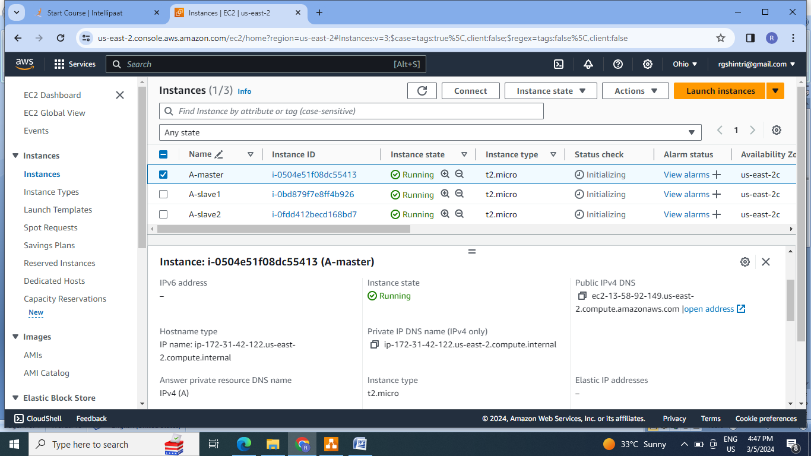

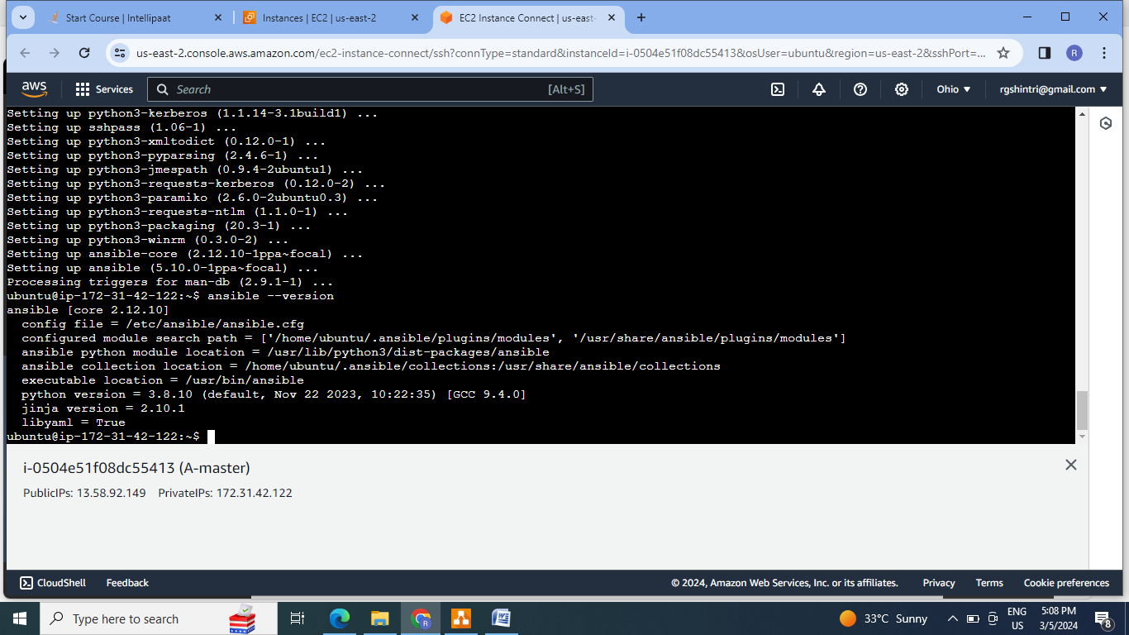

2.Establish the connection between master & both the slaves by ssh-keygen command at master.

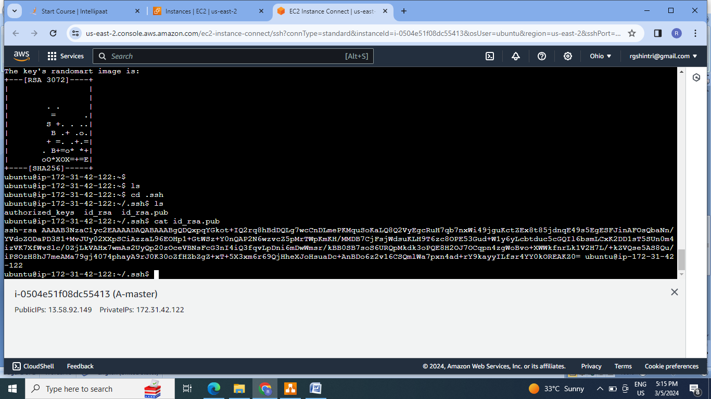

3.Copy the rsa key at master in to authorized key of both the slaves:

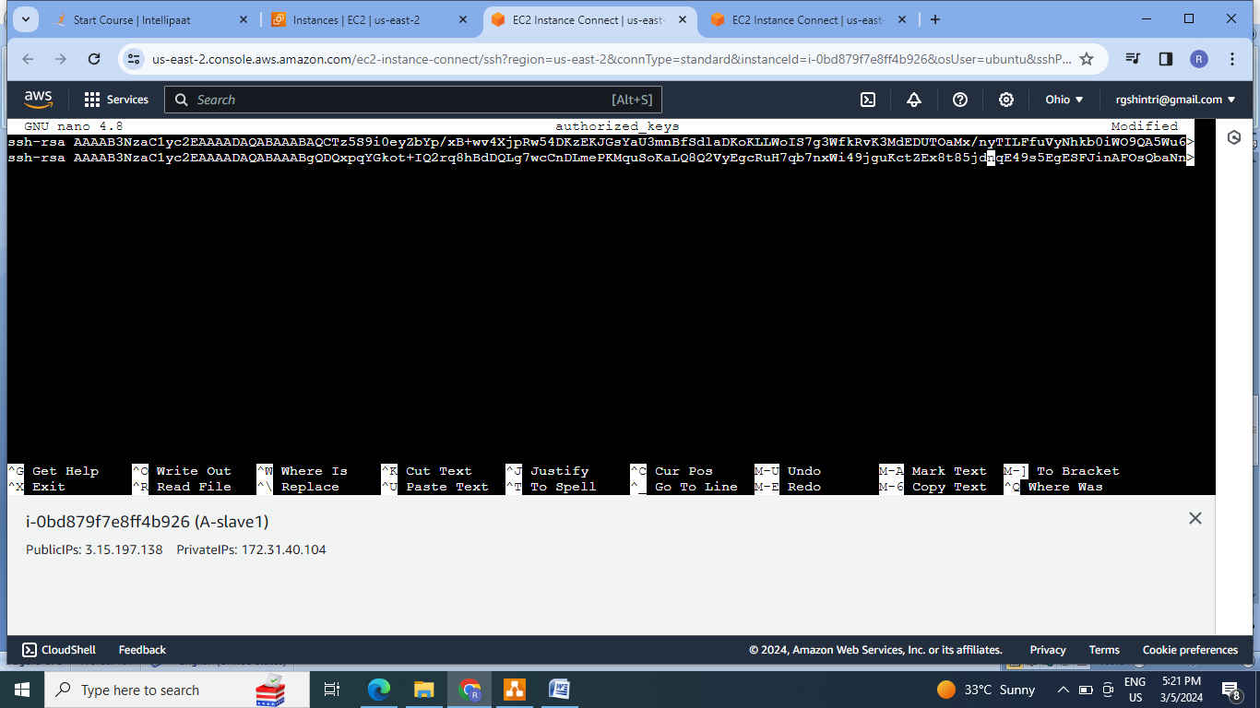

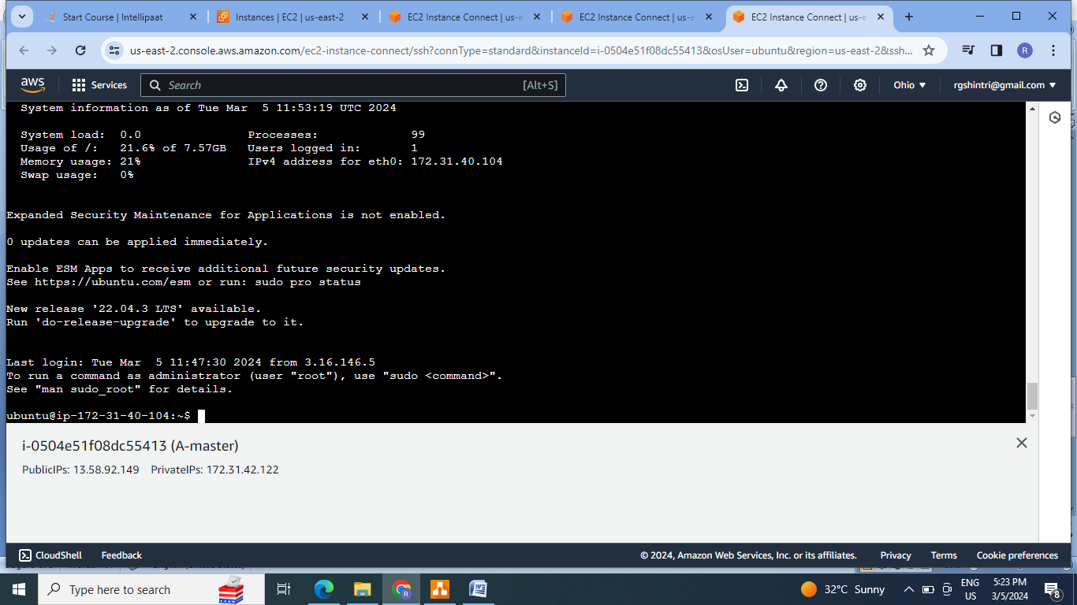

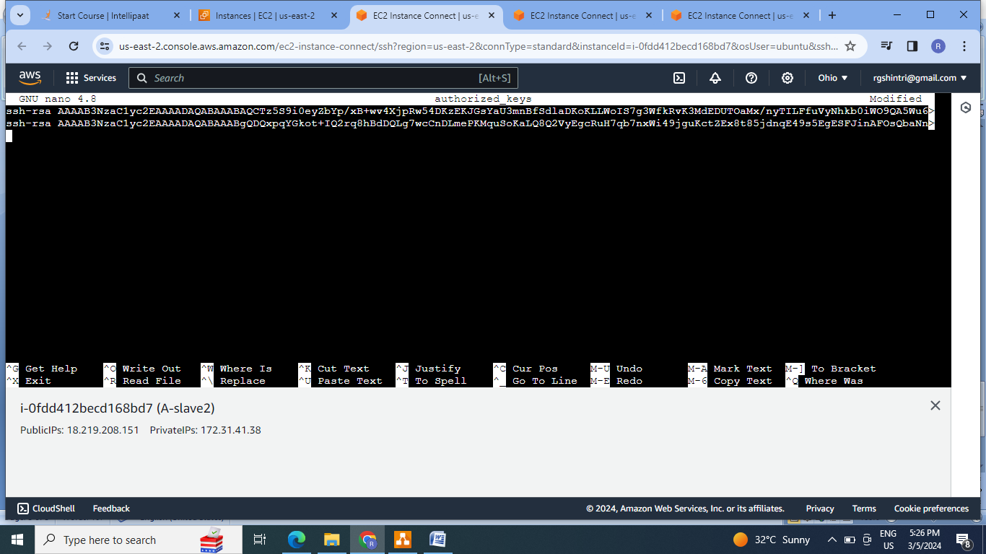

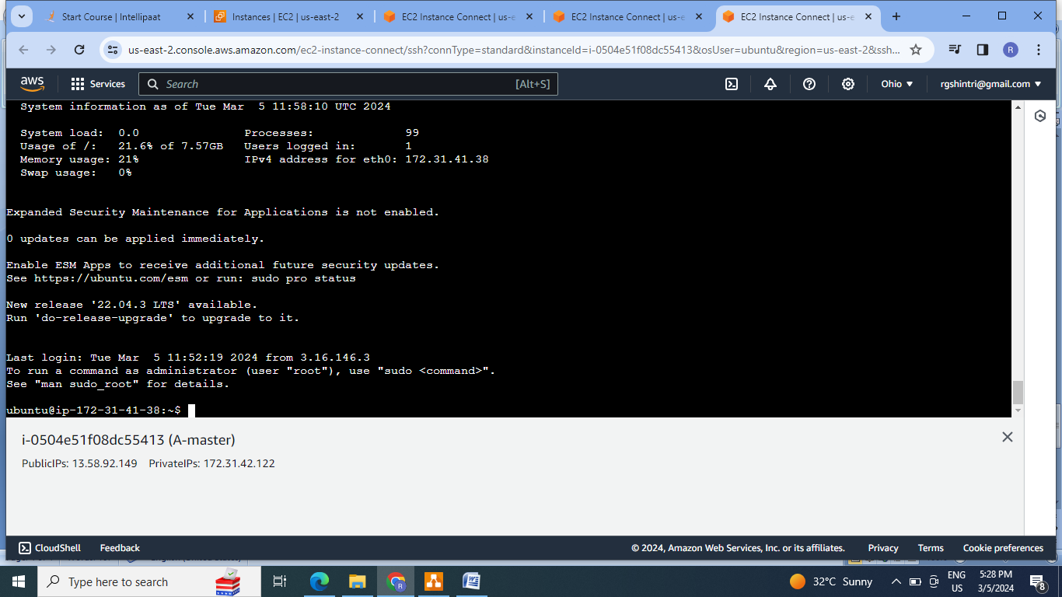

4.Add the slaves in the inventory file at default file & check for cluster formation:

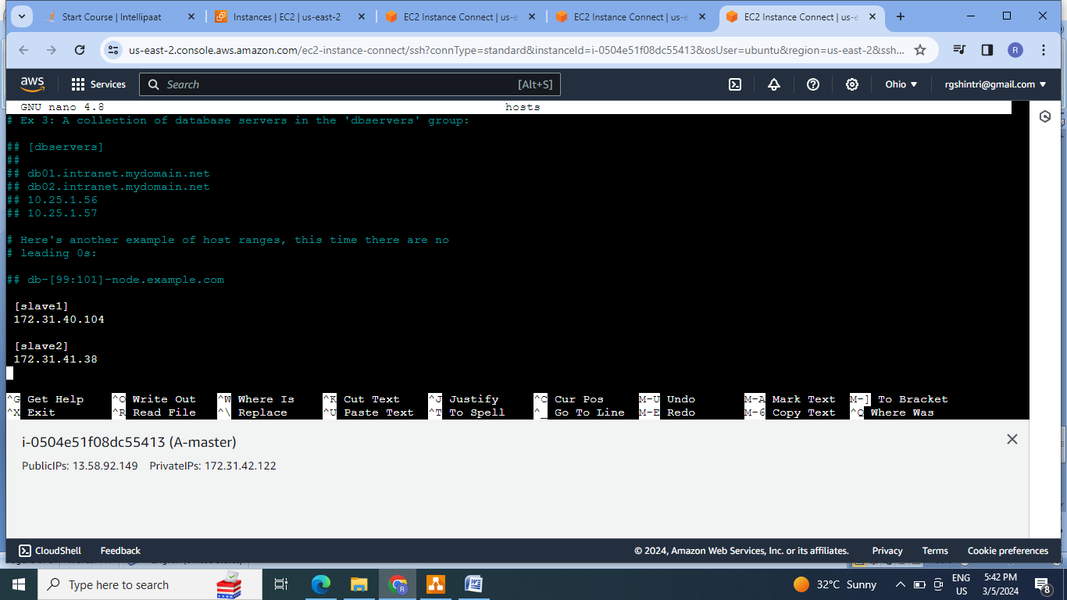

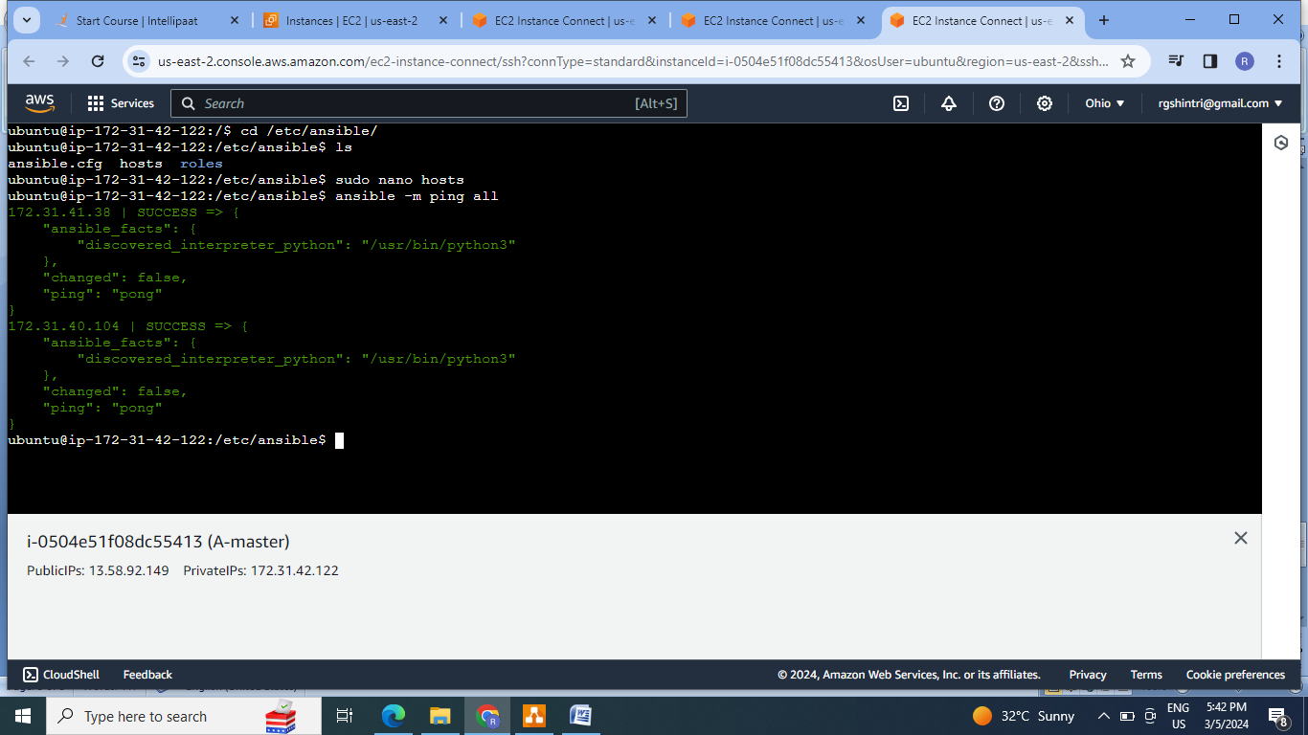

5. Write a playbook yaml file for installing java on slave1 & MySQL-server on slave2:

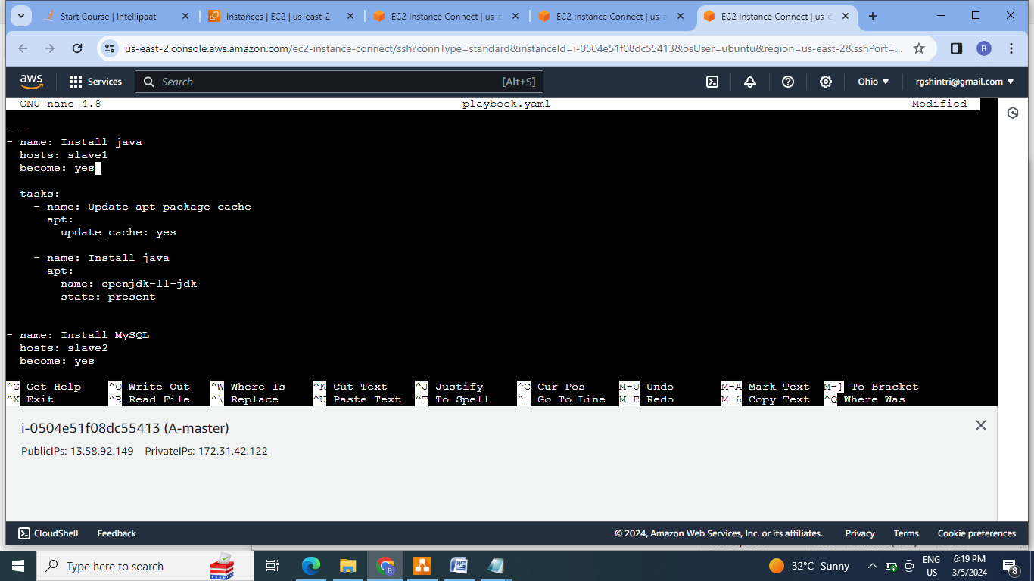

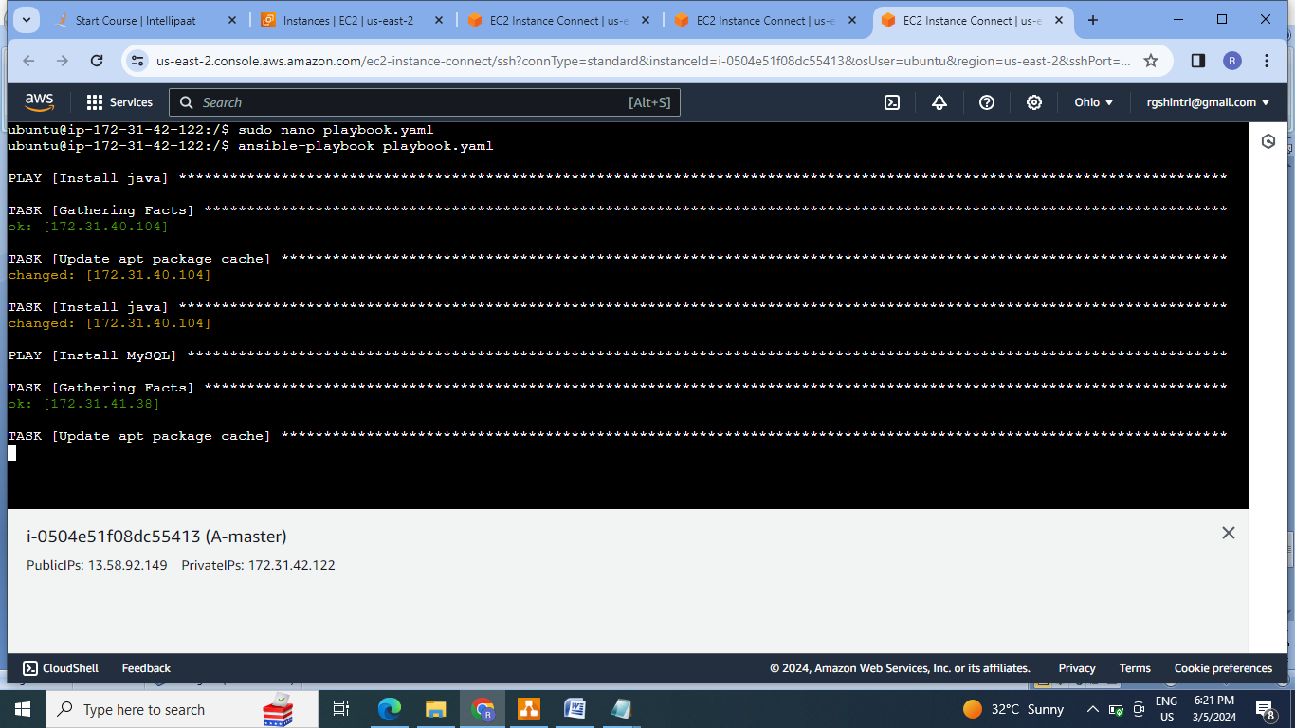

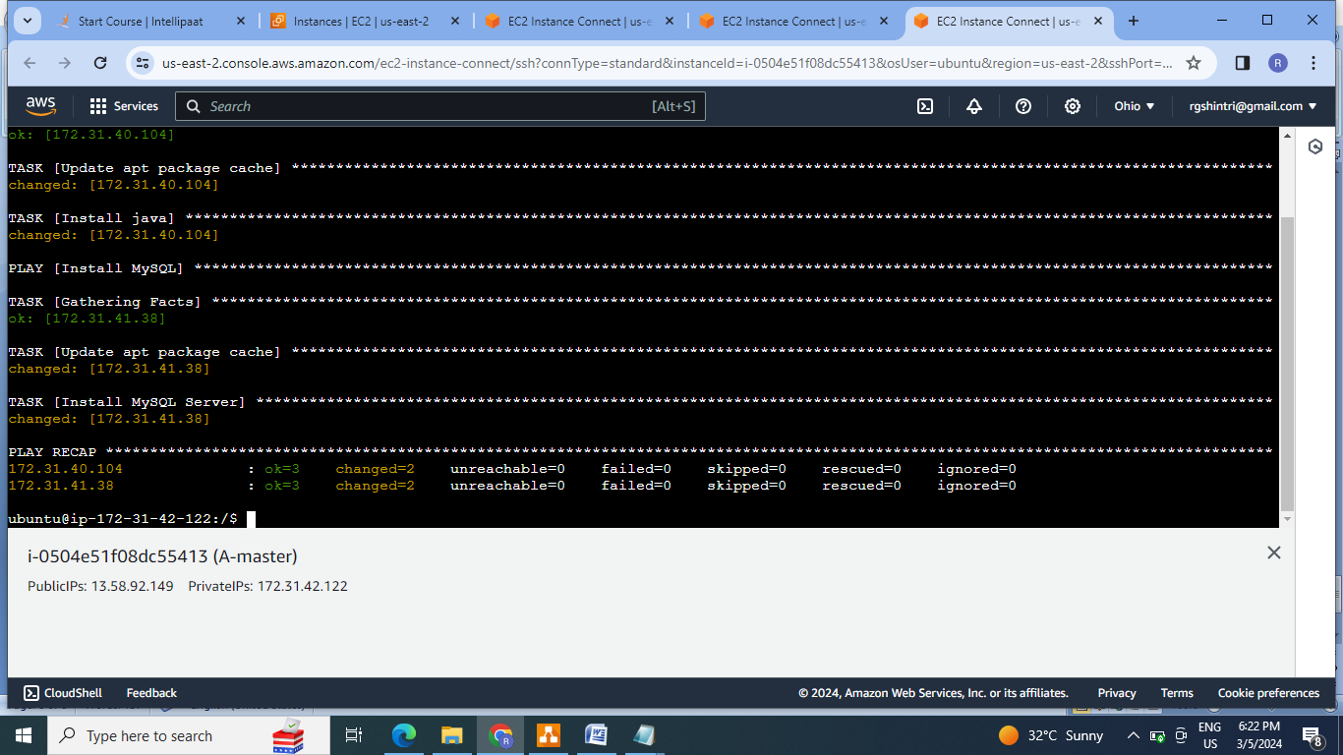

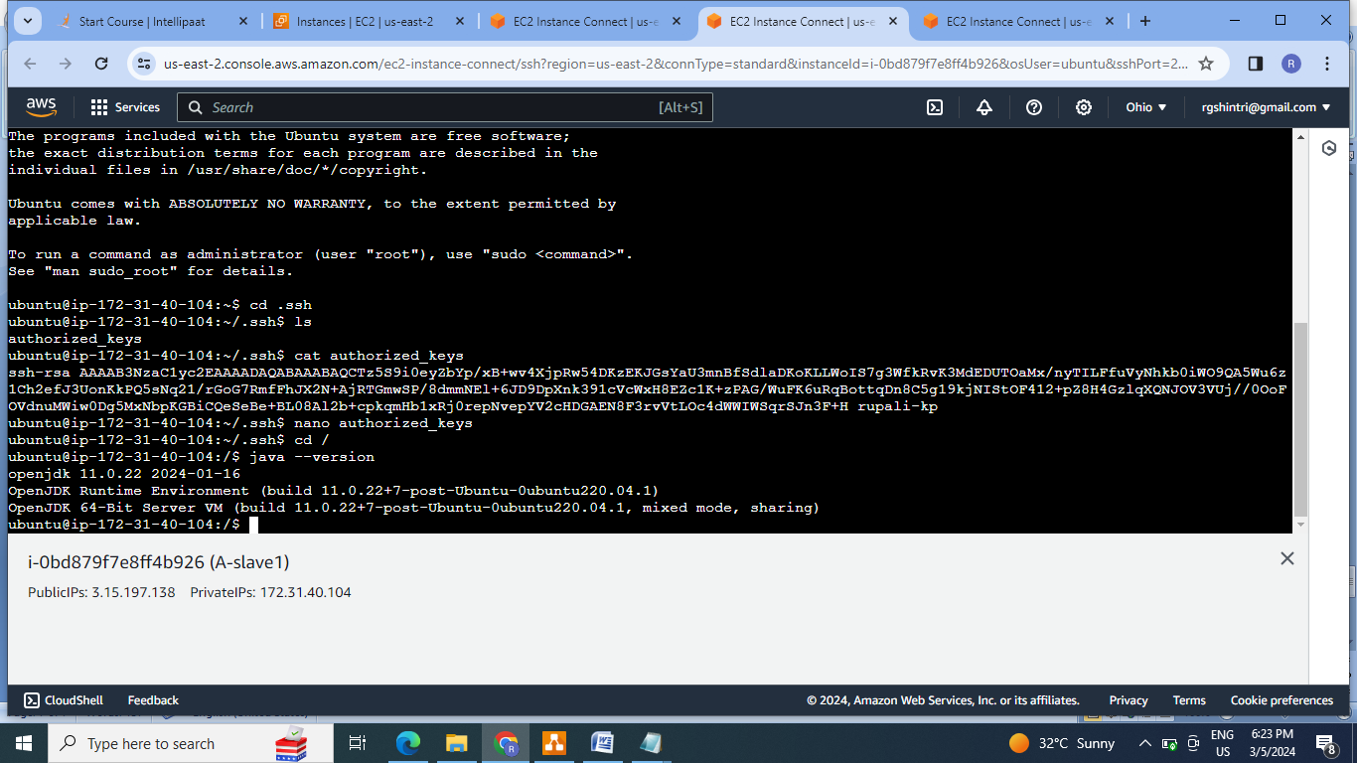

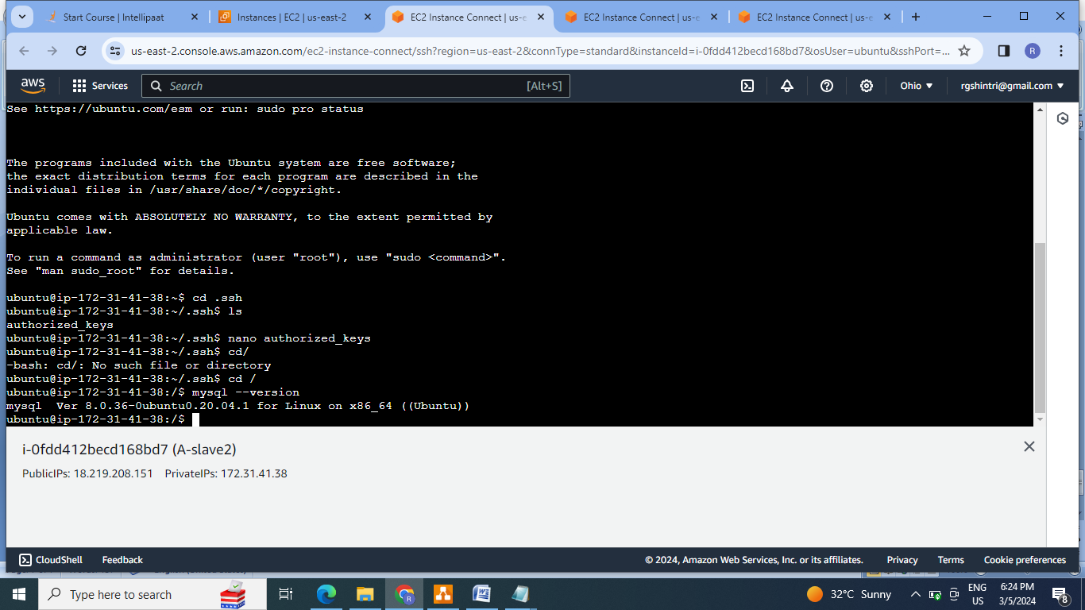

**B]Assignment 2**

● Create a script which can add text “This text has been added by custom script” to /tmp.1.txt

● Run this script using Ansible on all the hosts

Steps:

1.Create the script at master ,run it .

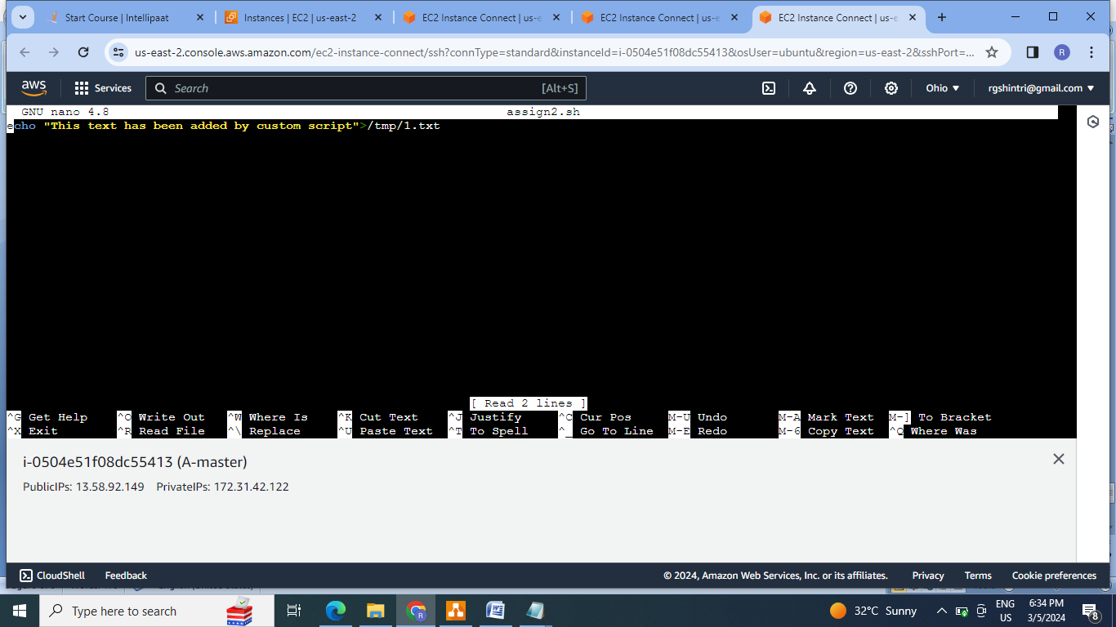

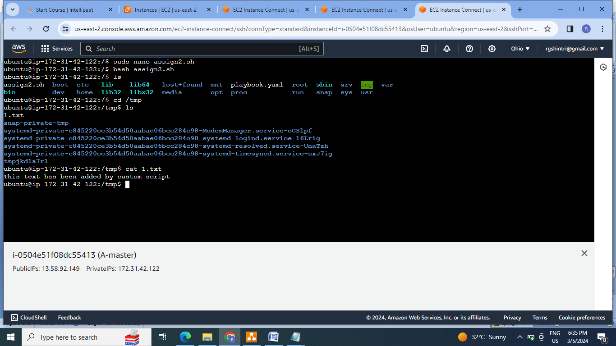

2.Create the playbook to run this script on all hosts:

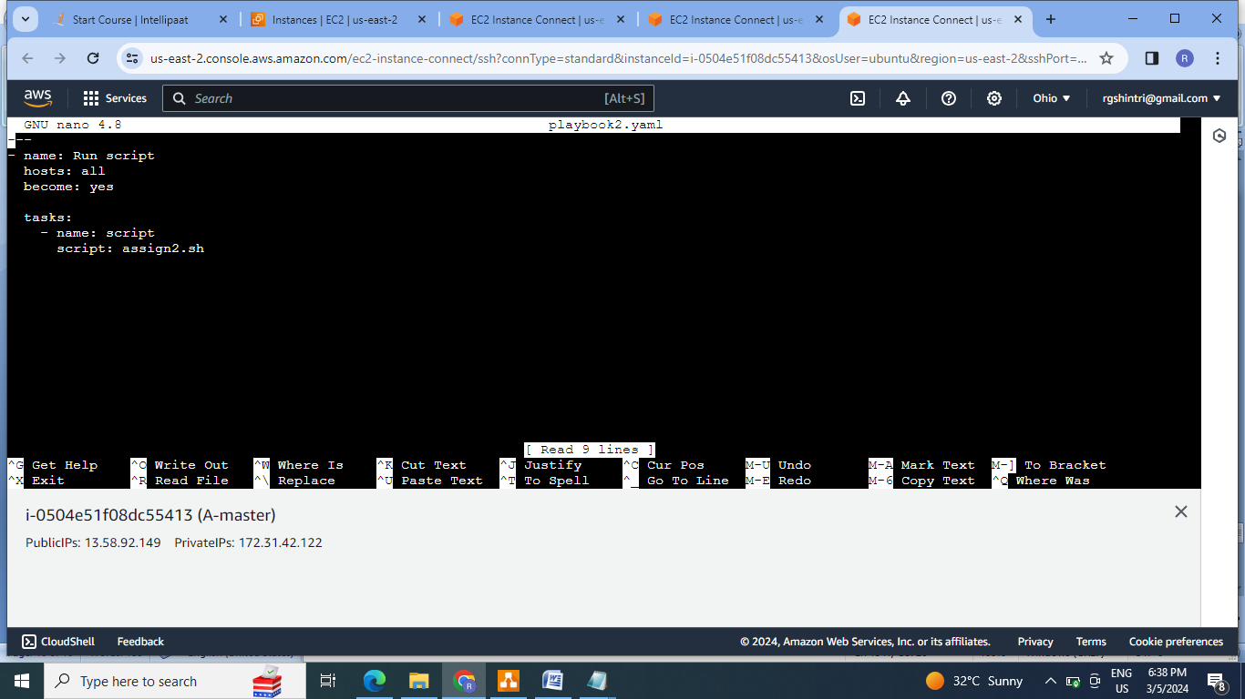

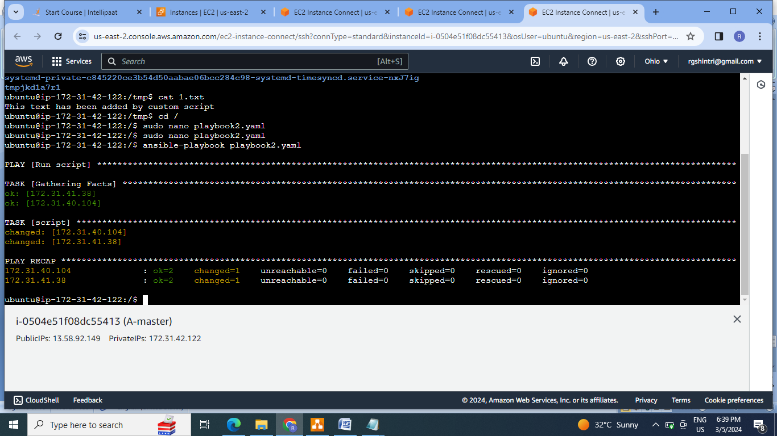

3.Check the script on both hosts:

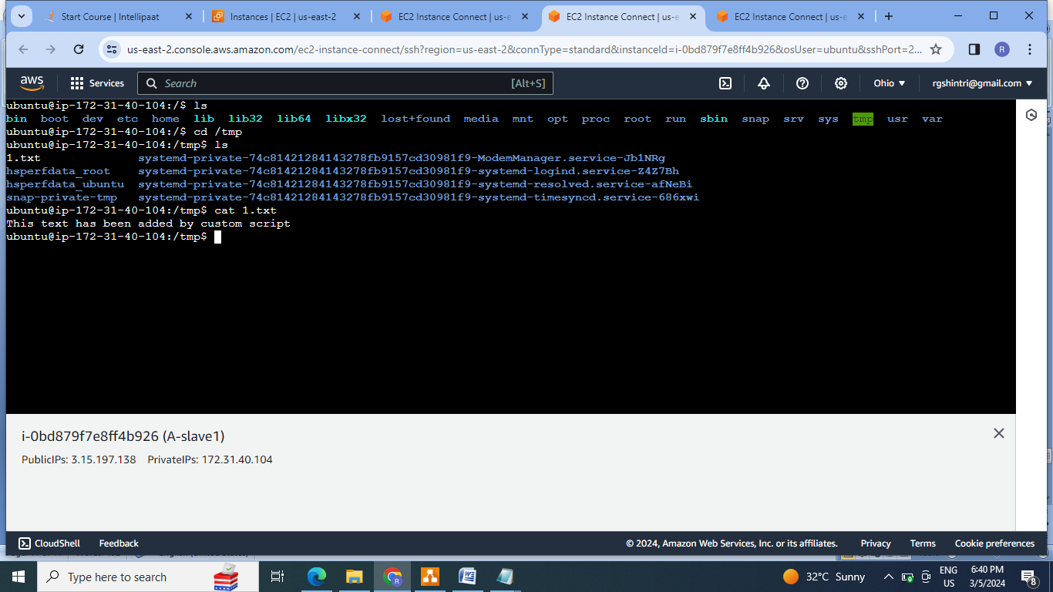

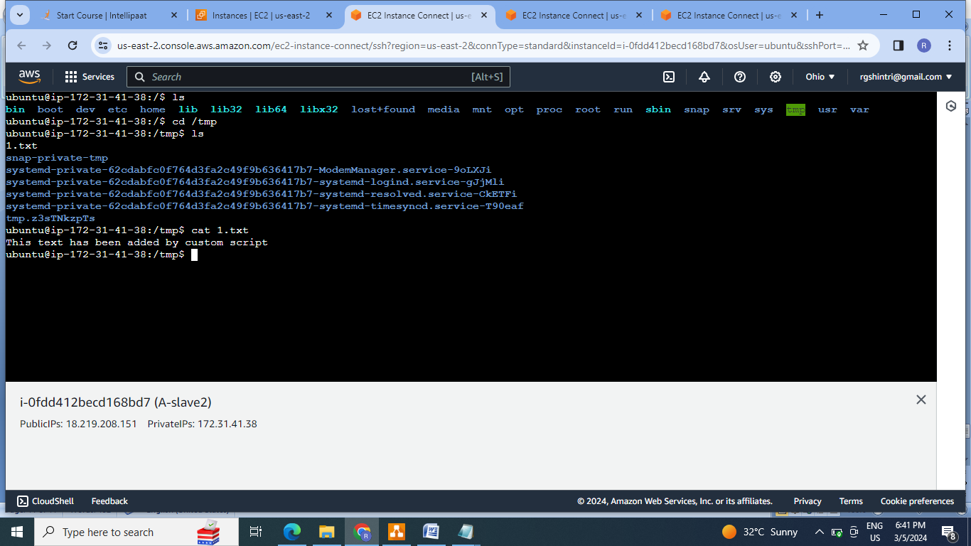

**C]Assignment 3:**

● Create 2 Ansible Roles

● Install apache2 on slave1 using one role and nginx on slave2 using the other role

Above should be implemented using different Ansible Roles

Steps:

1.Create the cluster .

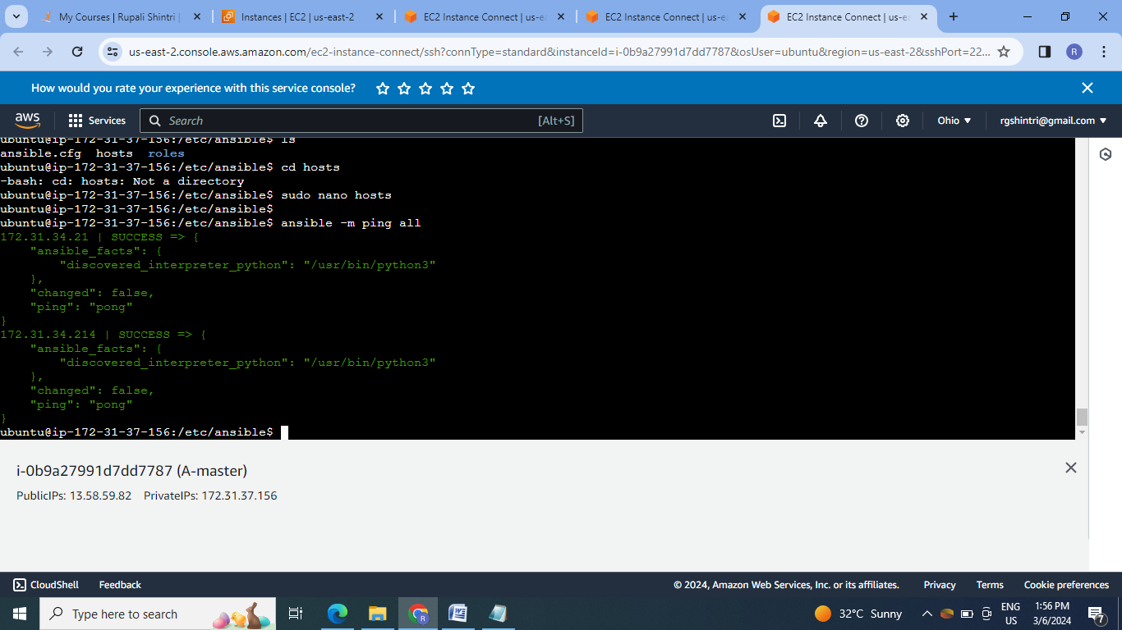

2.Create the roles:

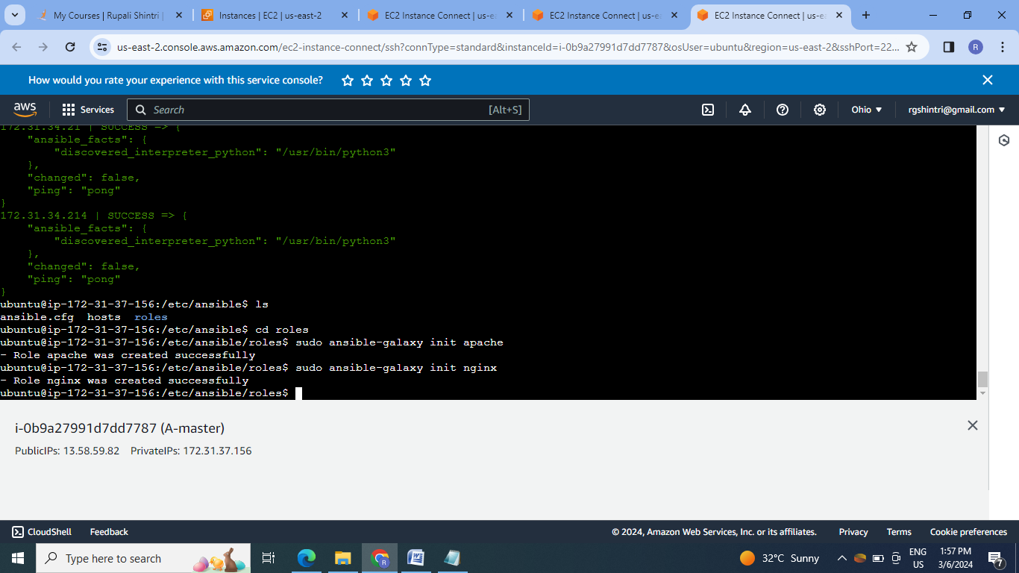

2.Inside the roles create the tasks files.

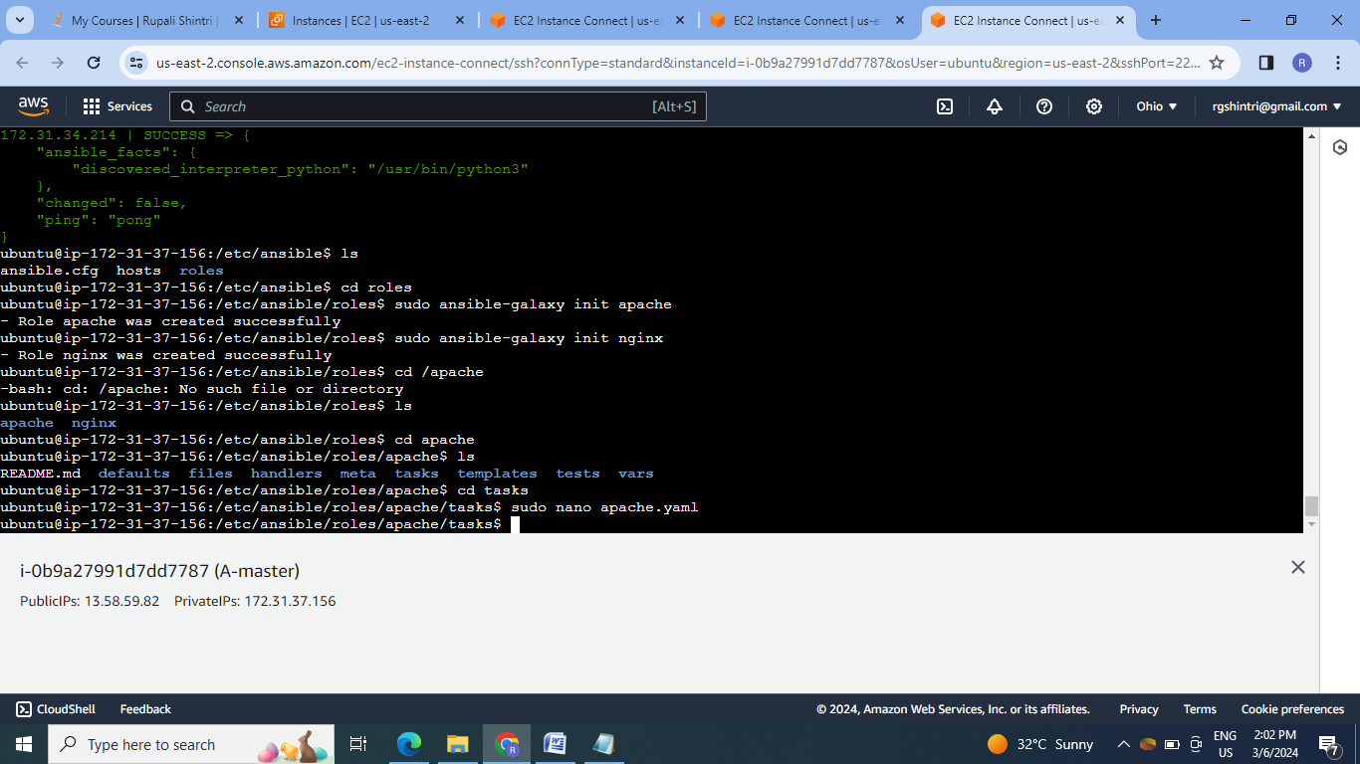

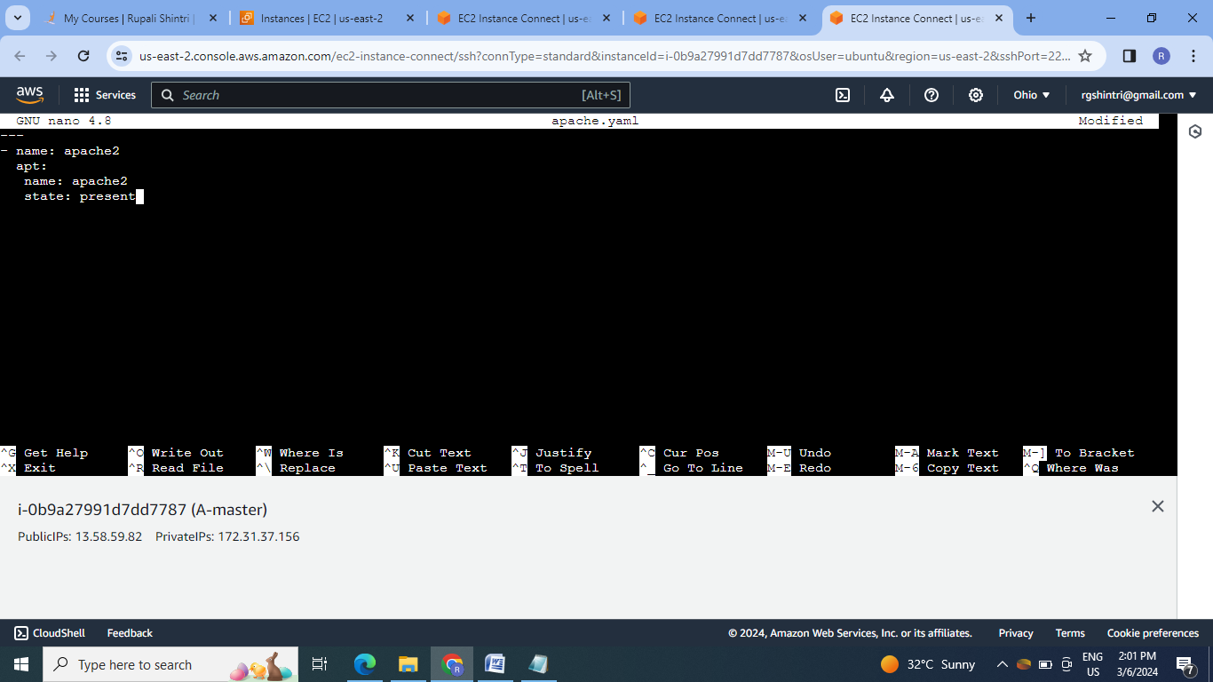

3.Save the task file in main.yaml file:

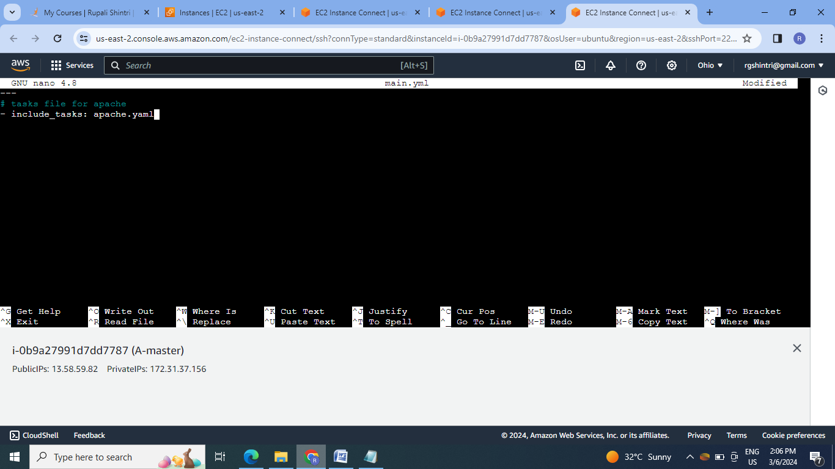

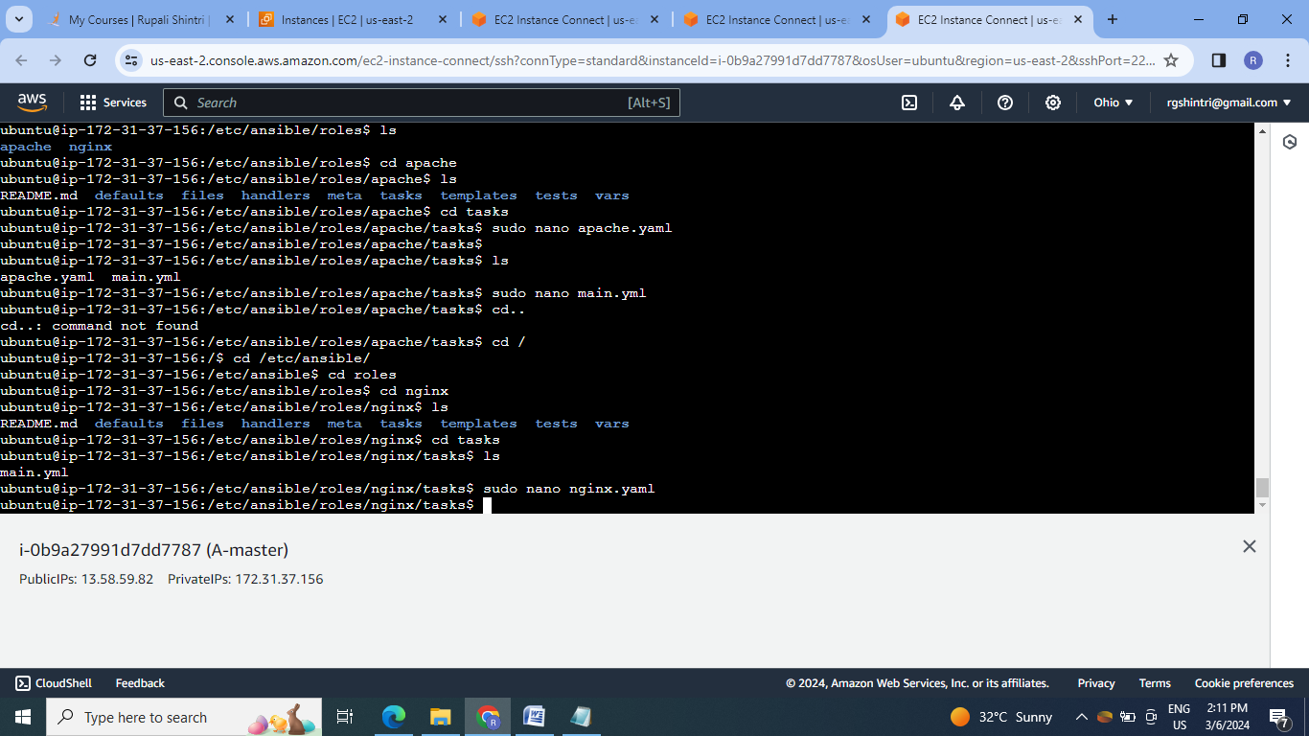

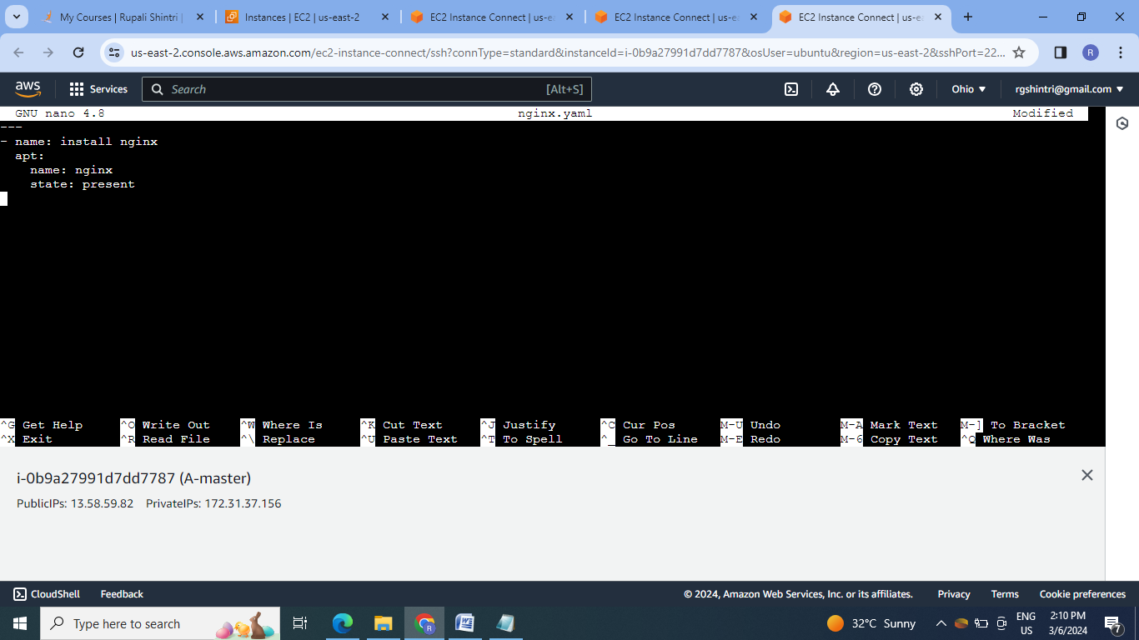

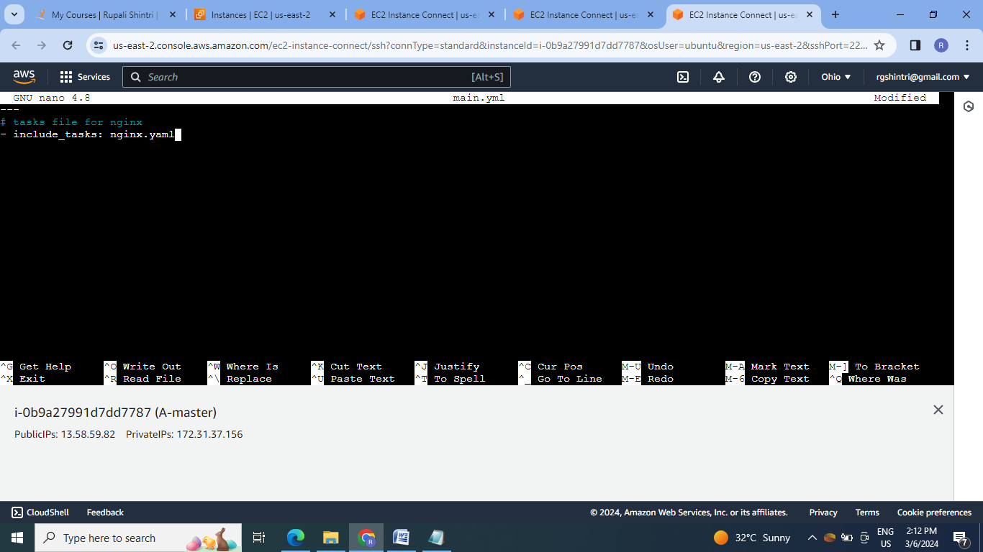

3. Create the playbook file to execute the roles:

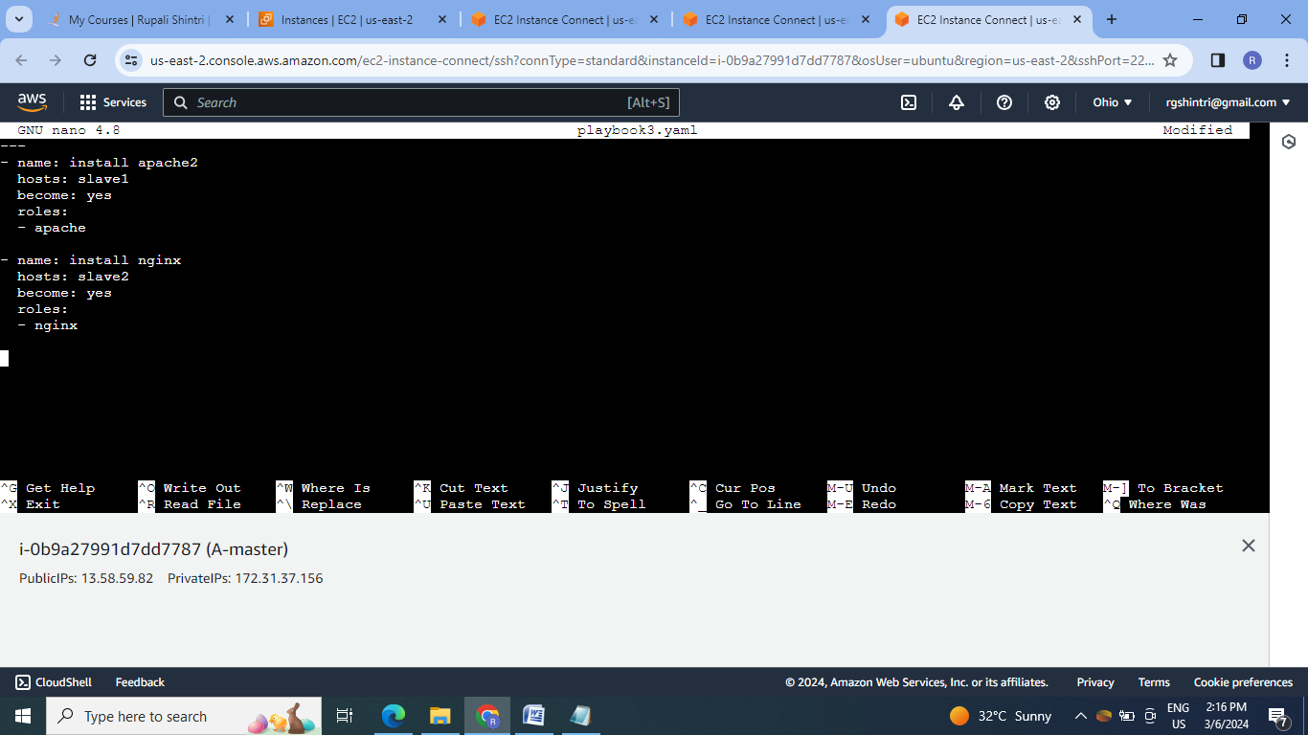

4.Execute playbook3 file:

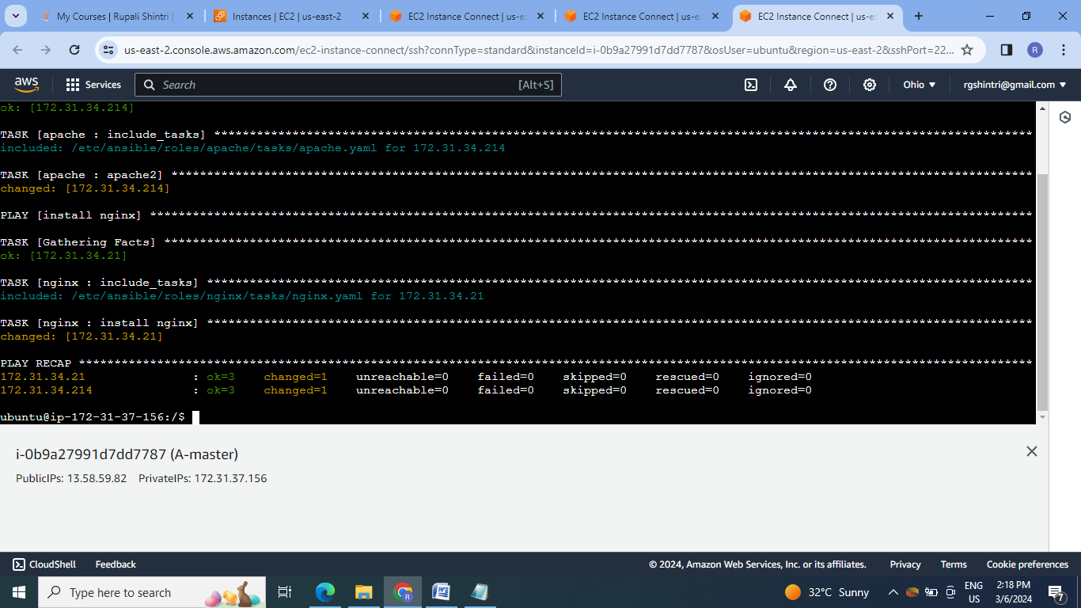

4.Check the services on respective slaves :

Slave1

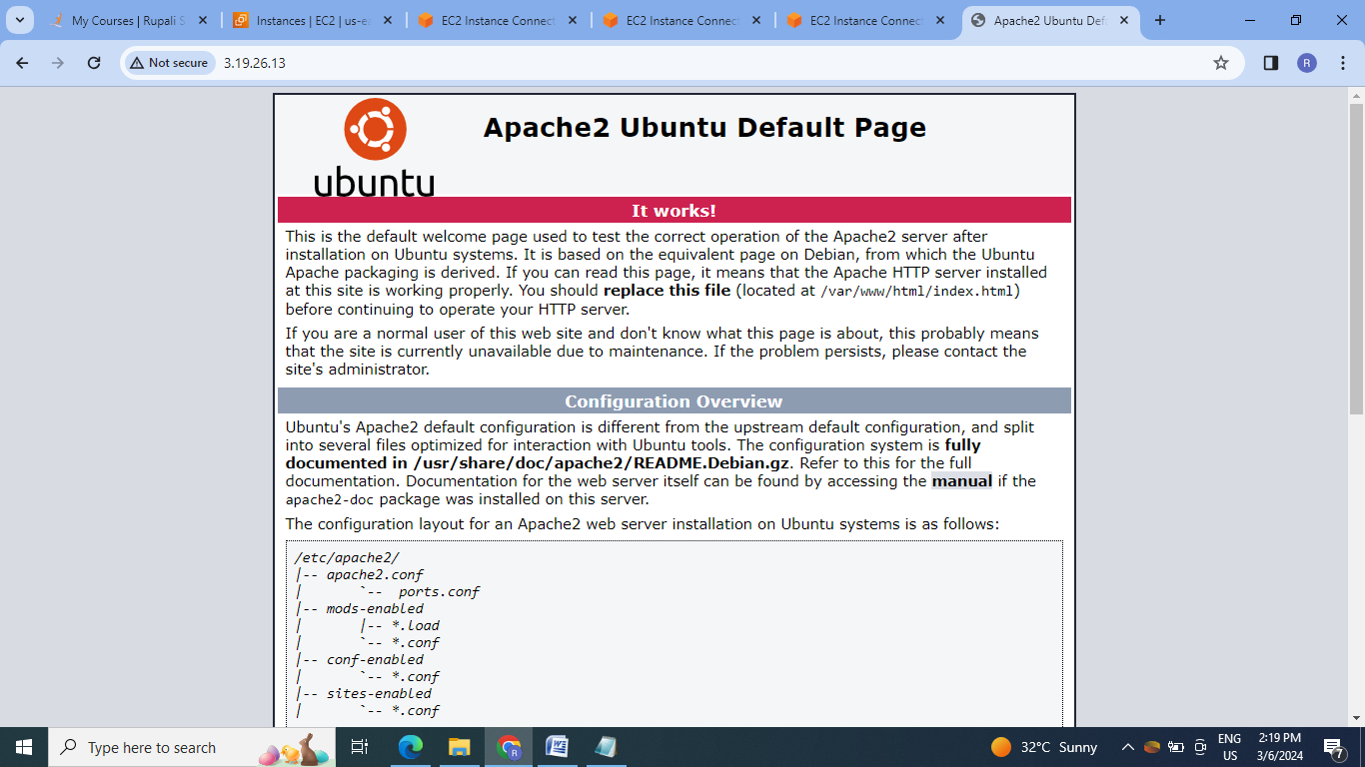

Salve2:

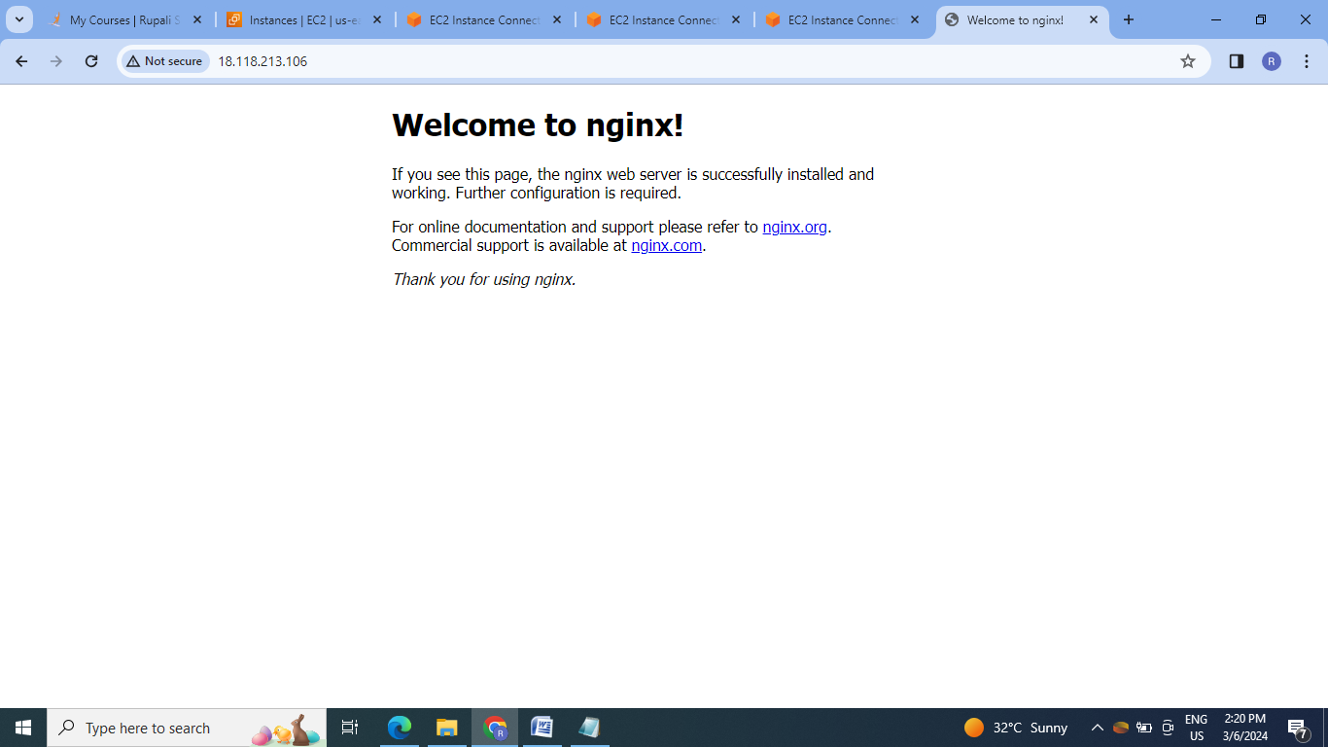

**D]Assignment 4:**

● Use the previous deployment of ansible cluster

● Configure the files folder in the role with index.html which should be replaced with the original index.html

All of the above should only happen on the slave which has nginx installed using the roles.

Steps:

1.Create the index.html file in nginx role & under the task create yaml file to copy this index file to the default nginx index file. & include this task in main.yml of nginx tasks.

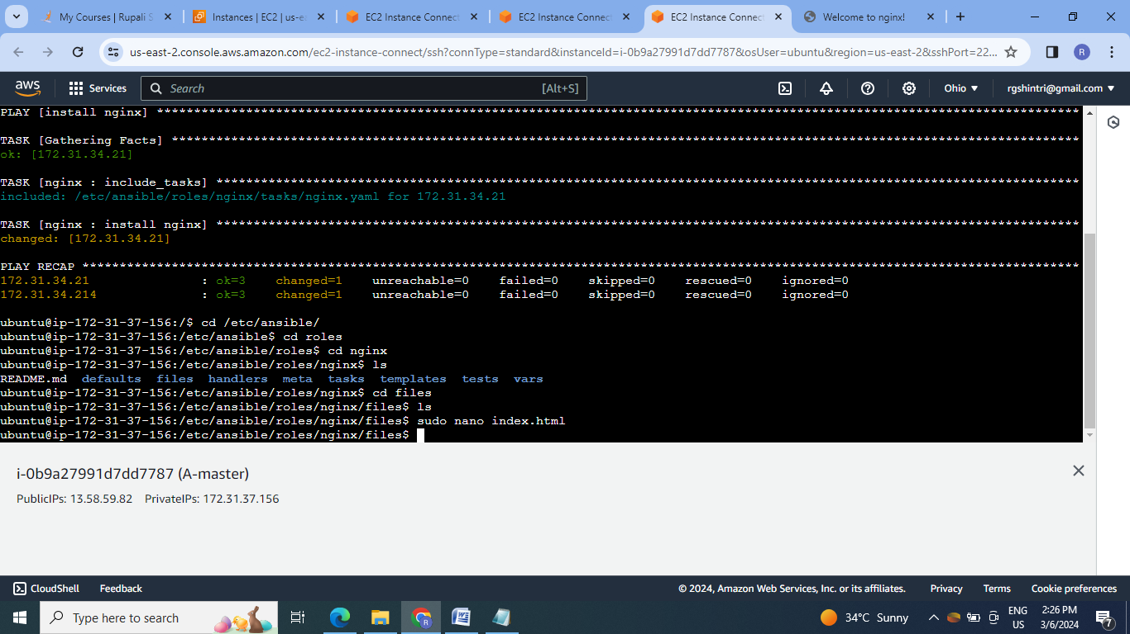

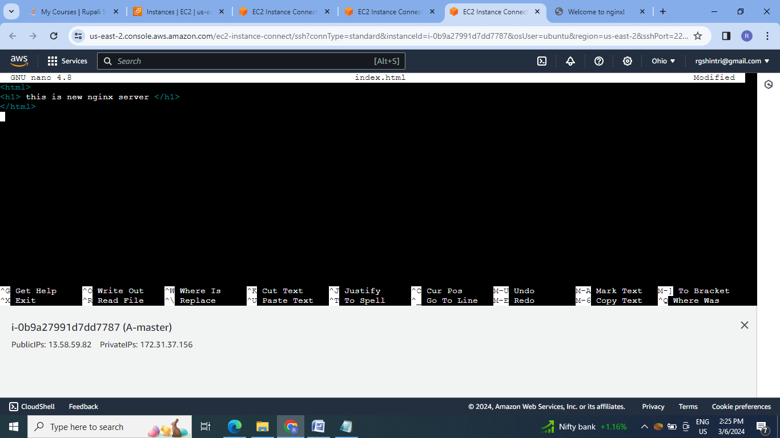

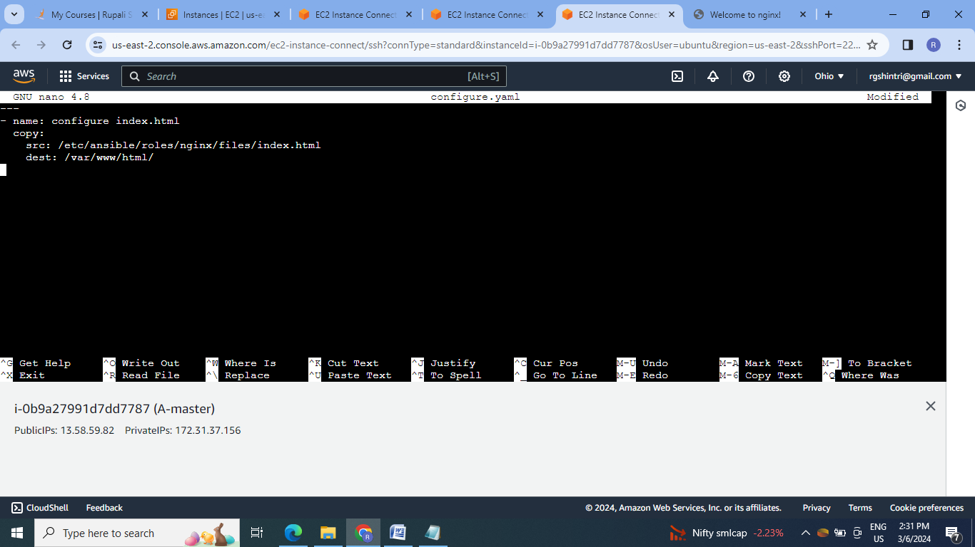

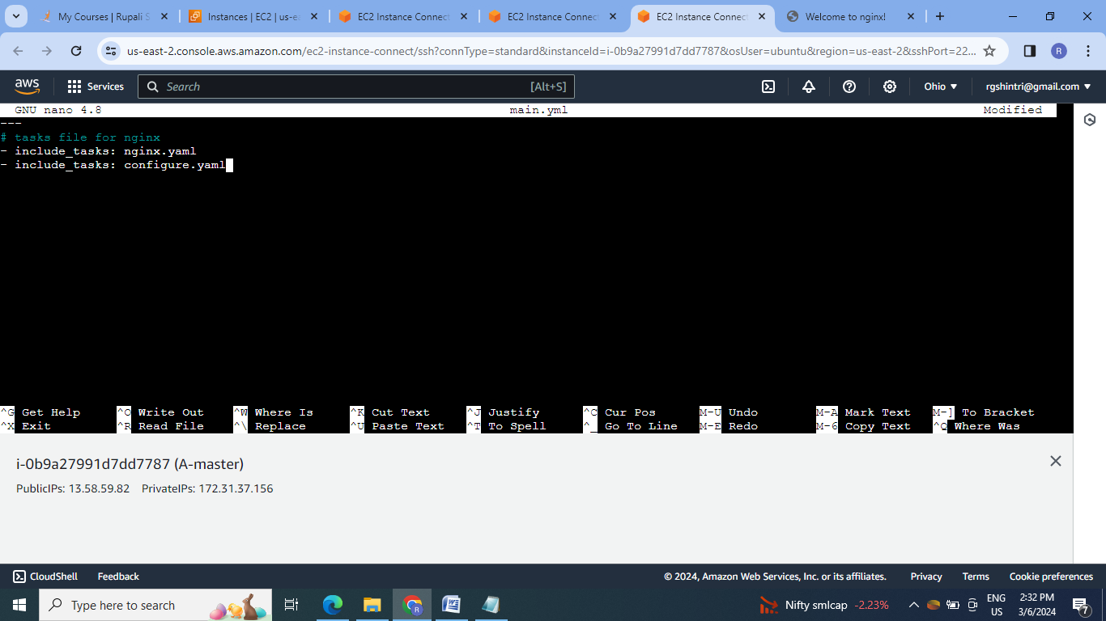

2.Run the previous assignment playbook3.yaml file.

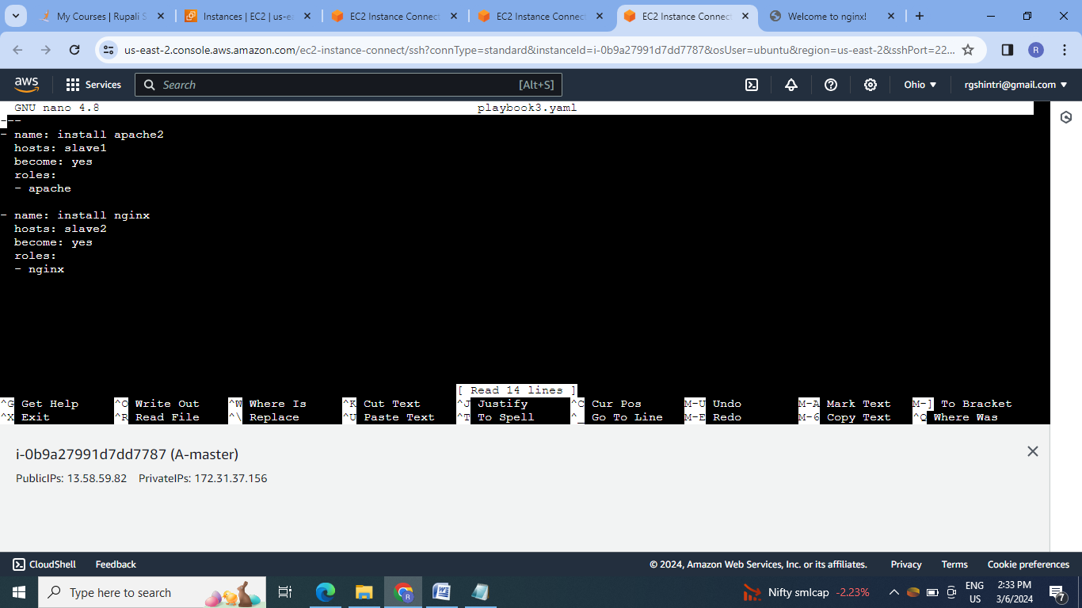

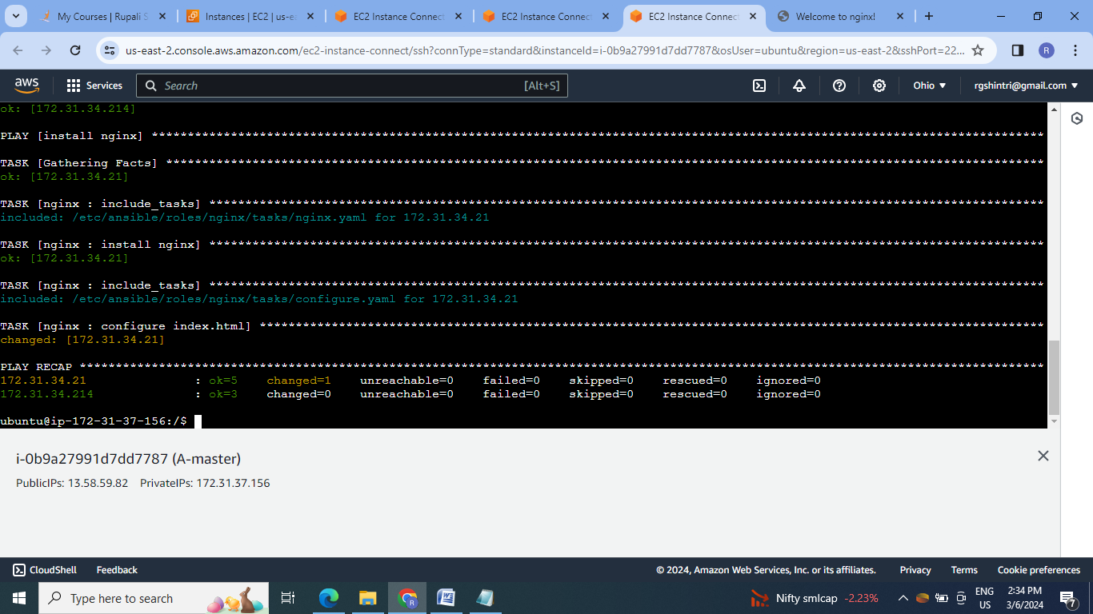

3.Check the web service nginx on slave2:



**E]Assignment 5:**

● Create a new deployment of ansible cluster of 5 nodes

● Label 2 nodes as test and other 2 as prod

● Install java on test nodes

● Install mysql-server on prod nodes

Use Anisble roles for the above, group the hosts under test and prod

Steps:

1.Create the 5 EC2 instances & create the cluster of 5 nodes:

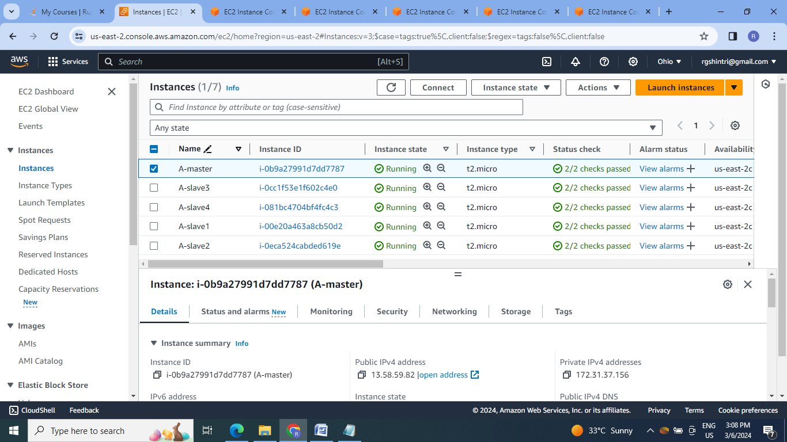

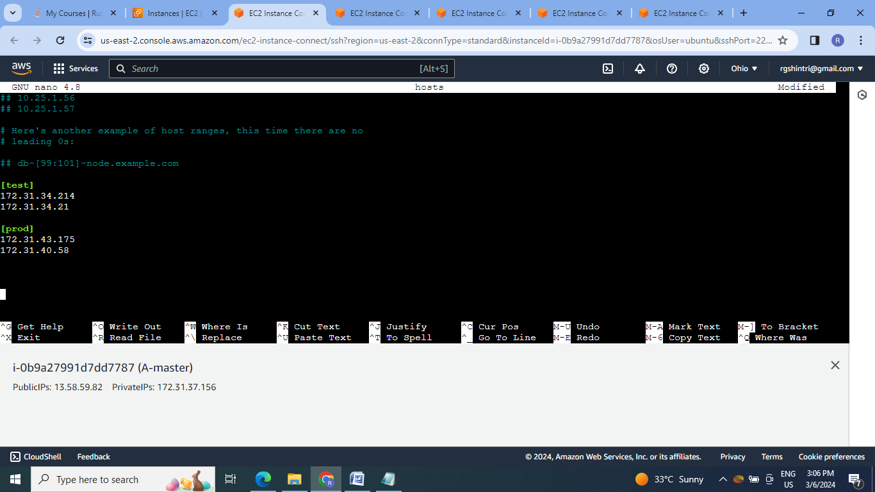

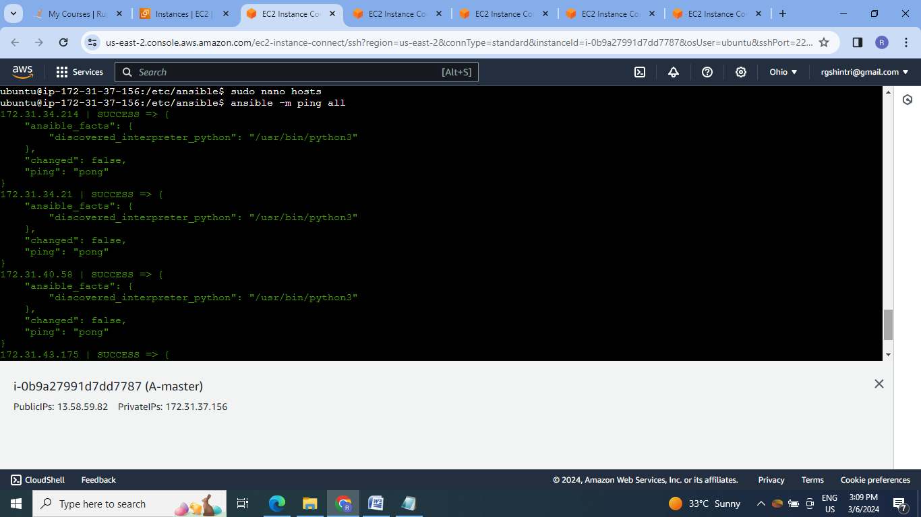

2.Create roles for java & mysql-server:

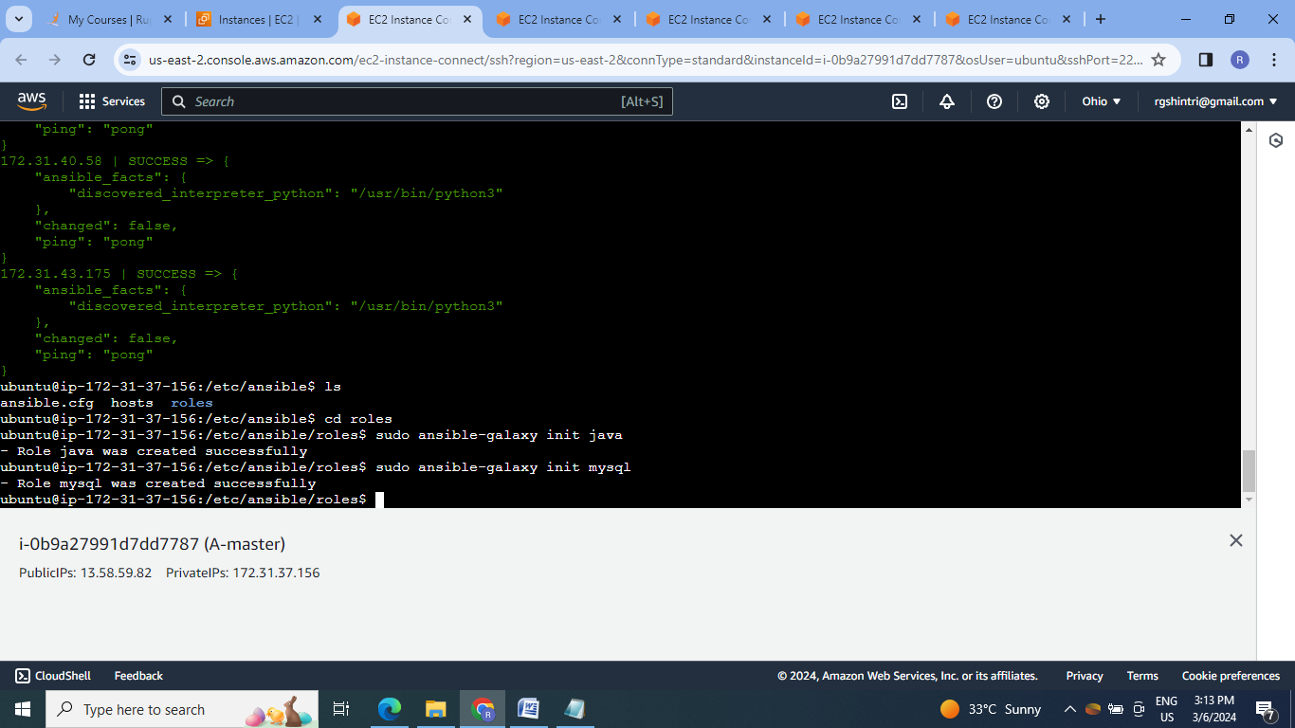

3.Create tasks files & include them in main.yml files of both roles:

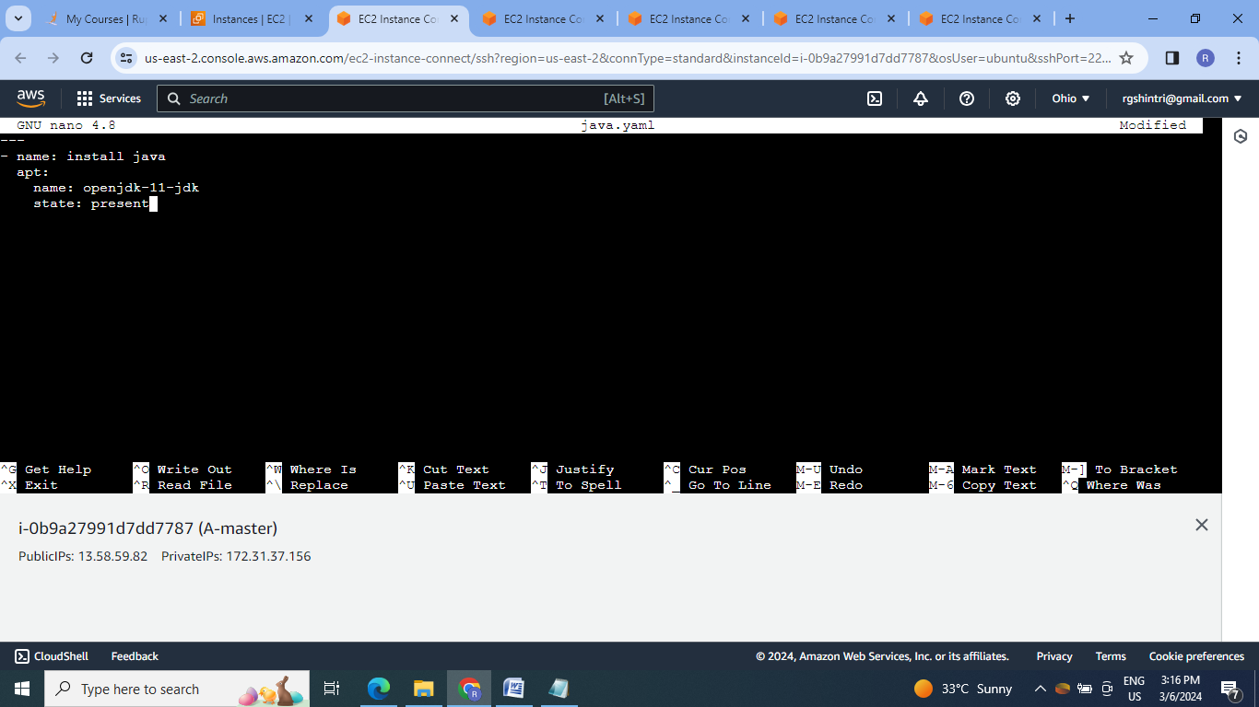

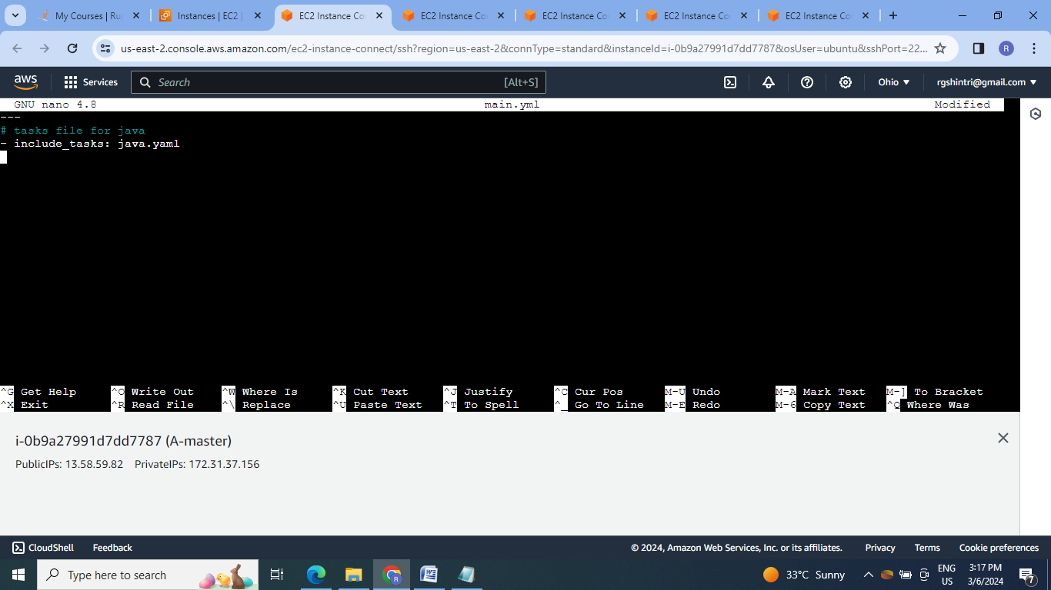

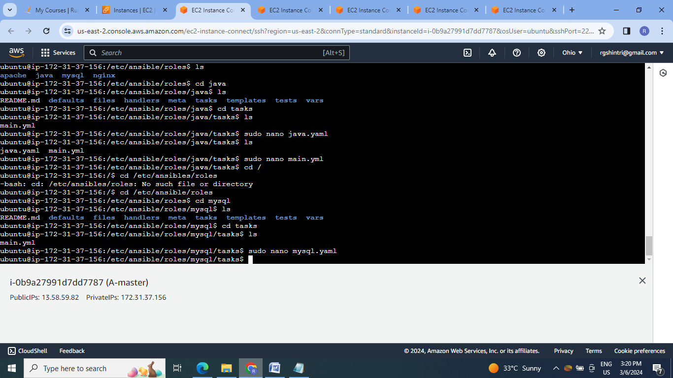

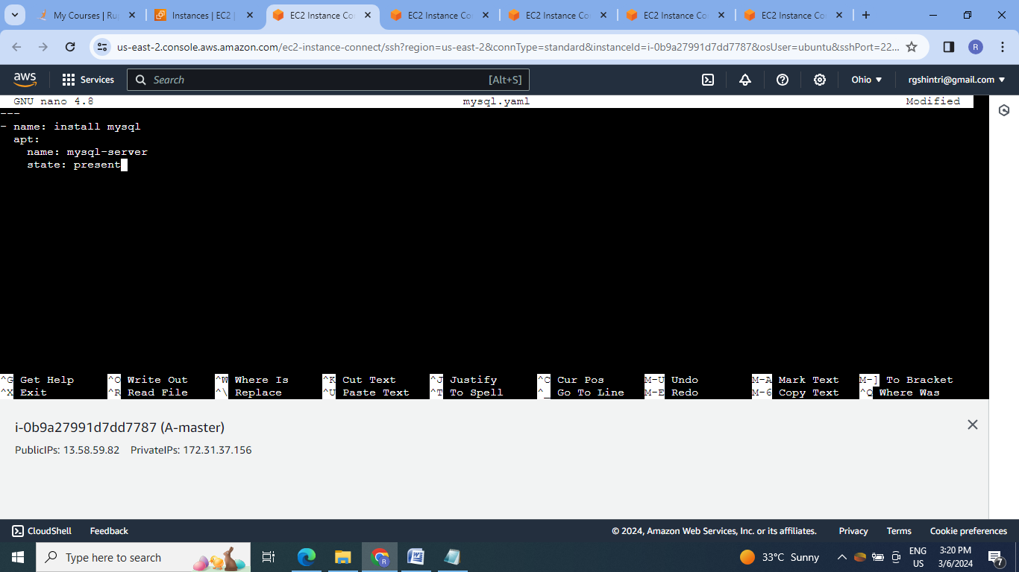

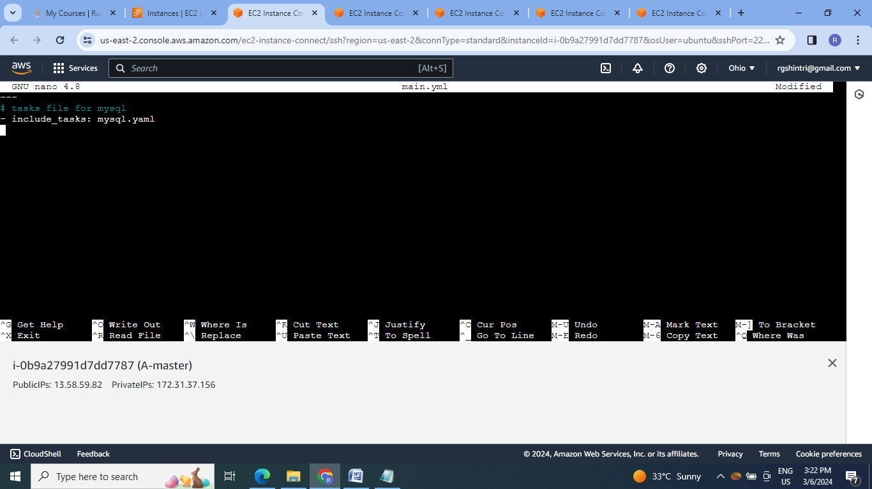

4.Create playbook file to execute the roles:

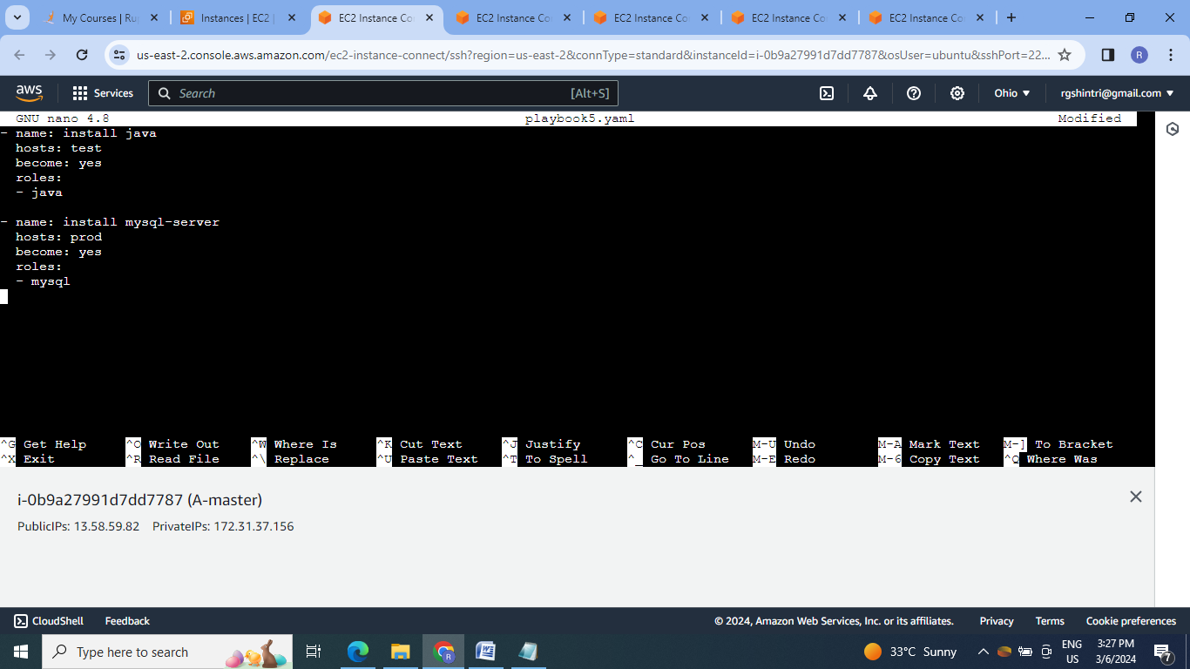  
5.Execute the playbook file:

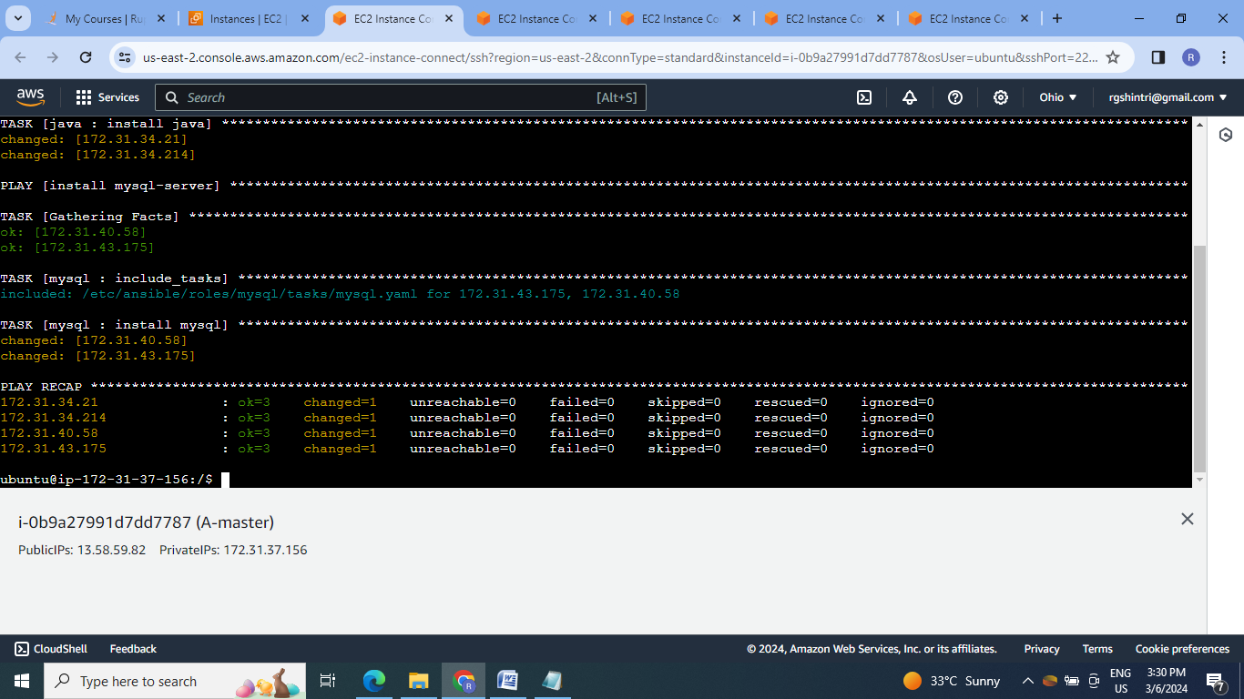

6.Check the services on respective slaves:

Java on slave 1 & slave 2:

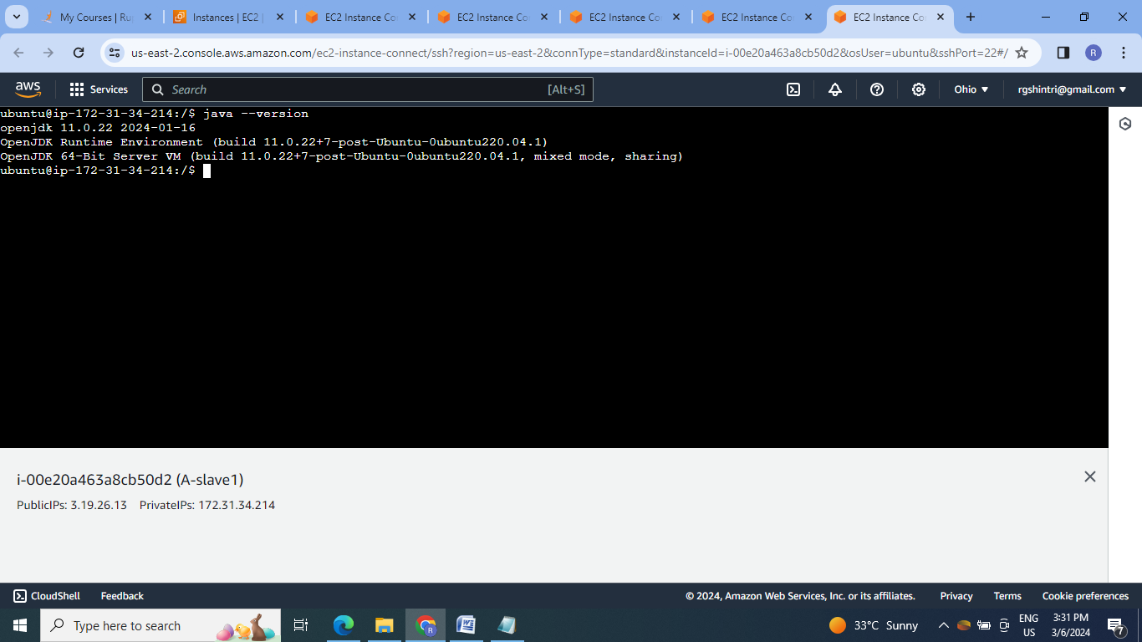

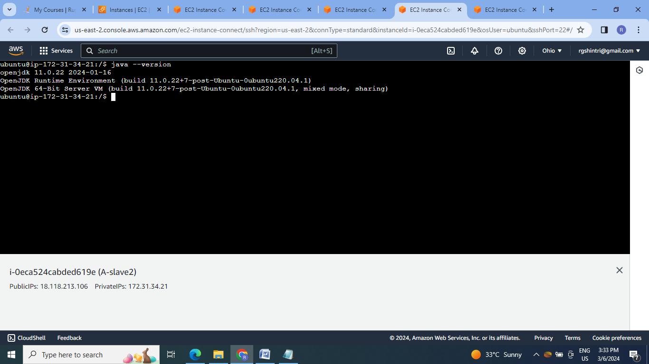

Mysql-server on slave3 & slave4:

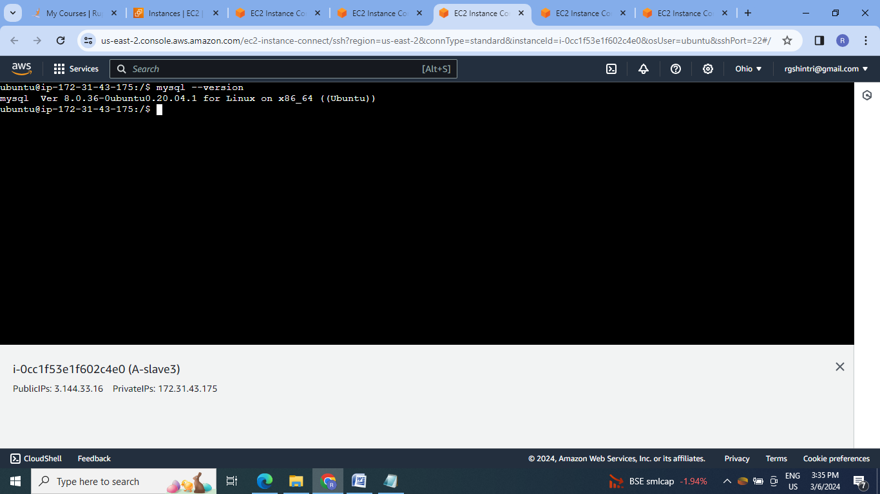

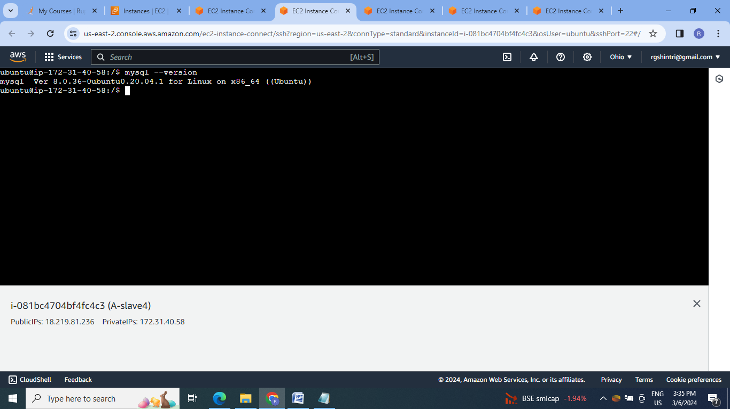

**Conclusion:** Ansible is the configuration managementtool which provides automation & used for application deployment, updates on servers, configuration management ,addition or deletion of users .

It does not depend on agent so its easy to deploy.

